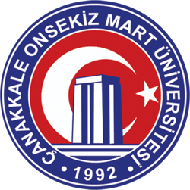

ÇANAKKALE ONSEKIZ MART UNIVERSITY

DISABLED STUDENT UNIT COORDINATORSHIP

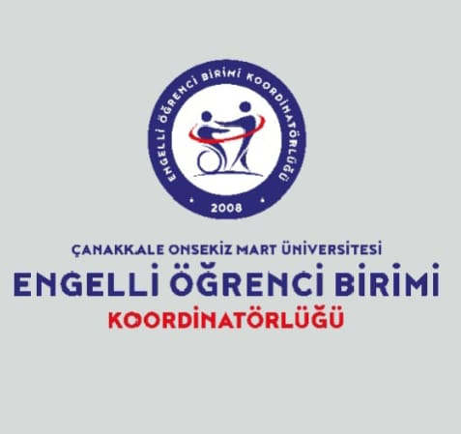

2024 ACTIVITIES

REPORT

Our activity report for 2024, as the unit coordinator, is presented here. Within the framework of our unit's mission and vision, we have made plans for 2025, and our improvement efforts for students with special needs studying at our university are ongoing.

Assoc. Prof. Dr. Sinan KALKAN
Coordinator

- GENERAL INFORMATION

- MISSION AND VISION

Mission
Our goal is to ensure accessibility for disabled students studying at our university so that they can use up-to-date information and technology, and to make our university a preferred choice for disabled students by providing them with the necessary equipment to support education, research and development, and application in accordance with national and international standards.

Vision
The aim is to identify the needs of disabled students studying at Çanakkale Onsekiz Mart University, to plan the necessary administrative arrangements according to these needs, to meet all their needs in academic, social and personal areas by creating the necessary infrastructure standards, to provide equal service, and to improve disability awareness among university staff.

- OUR POWERS, DUTIES AND RESPONSIBILITIES

The responsibilities of the Unit for Students with Disabilities are as follows:
1) To identify the educational, training, scholarship, administrative, physical, accommodation, social, and similar needs of students with special needs who are enrolled in our university programs, and to determine the necessary measures to meet these needs and offer solutions to eliminate them, and to carry out the necessary arrangements in coordination with other units or departments within the university.

2) To work on organizing the educational environment for university students with special needs affected by disabilities in a way that does not hinder their academic, physical, and social lives; this includes providing necessary tools and equipment, preparing special teaching materials, and arranging other educational, research, and accommodation facilities.

3) To engage in publishing activities for students and faculty members at the higher education level, to prepare documents informing faculty members about their specific needs, the limitations they entail, and the necessary adjustments, to organize awareness-raising events and training sessions, and to provide consultancy services to relevant parties.

4) To develop programs and projects, and organize seminars, conferences, and similar activities to increase awareness and sensitivity in the field of special education.

5) To prepare and implement the unit's work program, determine the necessary budget requirements for activities, and prepare and submit the annual activity report to the vice-rector to whom it is affiliated.

6) To create a website that includes publications, documents, and information on issues within the scope of the disabled student unit's duties and activities, enabling disabled students studying at universities to express their problems and requests, and facilitating communication with the relevant unit.

7) To monitor the implementation of the decisions made and the strategies determined.

8) To work towards providing free assistive devices and equipment to students with special needs who are experiencing economic difficulties and are affected by disabilities.

9) To ensure that all students are subject to fair and accurate measurement and evaluation, to provide equal opportunities, and to make the educational process meaningful for these students as well; to provide disabled students with the necessary time, place, materials, and accompanying reader for exams, and to take necessary measures and make arrangements according to the differences arising from the nature of the disability.

10) To take measures to ensure that informative books providing information about employment opportunities and professions are prepared and distributed to these students.

11) To identify students with disabilities and special needs who have been accepted to our university programs during the registration process.

12) To ensure that the university campus and the buildings and open spaces within the campus are accessible to these students.

- ADMINISTRATIVE INFORMATION
- Physical structure
The Disabled Student Unit Coordination Office is located in the building at Çanakkale Onsekiz Mart University, Terzioğlu Campus, Central Library Ground Floor. The Coordinator represents the unit and reports directly to the Rector. Disabled Student Coordinators in academic units , along with deans/deputy directors providing administrative support, are responsible to the Disabled Student Unit according to the Disabled Student Unit Regulations. The unit has a management board and a quality committee.
1.2 - List of movable assets
3 tables, 3 coffee tables, 2 cabinets, 8 chairs, 1 coat rack.

1.3 - Organizational structure

2- Information and Technological Resources
2.1 - Computers
Number of Computers in the Disabled Student Unit Coordination Office
Computer Numbers
Type | Piece
Number of desktop computers | 2
Number of portable computers | 1
Total | 3

2.3 - Other Information and Technological Resources
Disabled Student Unit Coordination Office Other Information and Technological Resources
Gender | For Administrative Purposes  (Piece) | For Educational Purposes (Quantity) | For Research Purposes (Quantity)
Projection​ |  | 1
Induction Device |  | 3
Braille Alphabet Printer |  | 1
Copying machine | 1

3. Academic Staff
Years | Prof. | Associate Professor | Assistant Professor (Dr.) | Lecturer​ | Research Assistant | Total
2024 | 1 | 3 | 14 | 17 | 4 | 39

- OBJECTIVES AND GOALS

  - Unit's Aims and Objectives
Our main goal is to create equal opportunities for disabled individuals studying at our university to participate in academic and social life, and to transform our campus into an accessible living space with its physical, academic, and social facilities. The 'Accessible Office' will be a center aimed at eliminating the obstacles that our disabled students face in their academic, social, and cultural lives, enabling them to take a more active role in university life and increase their success. This center will provide counseling, guidance, and support services to students with special needs.

  - Key Policies and Priorities
To ensure that students with special needs studying at our university can benefit to the fullest extent from our social spaces and learning processes.

- INFORMATION AND EVALUATION REGARDING ACTIVITIES
ACTIVITY: 1
Event Name: Final Evaluation and Orientation Meeting of 2023 with Disability Unit Coordinators
Event Date and Time: Thursday, December 28, 2023, 10:00 AM
Event Location: Troia Cultural Center Amphitheater A
Event Topic: Final evaluation and orientation meeting for 2023.
Activity Program: Files containing the 'Disability Unit Coordinators Evaluation Survey Form, Building Observation Form, Lists of Disabled Students in Schools' were distributed to unit coordinators. They were asked to evaluate the descriptive questions in the forms with yes or no options and provide feedback. For the YÖK (Council of Higher Education) flag awards competition and to analyze shortcomings in the faculties or colleges of our university, the Disability Unit wrote articles under two main headings: “Physical, Educational and Administrative Needs” and “Accessibility in Education and Socio -Cultural Activities,” and these were sent to the units. A question-and-answer session was held regarding the problems and proposed solutions for disabled students.
Activity Objective: A primary objective is to identify the problems faced by students with disabilities and propose solutions, as well as to determine the physical, educational, and administrative needs of schools.
Target Audience: Unit Coordinators
Speakers/Participants in the Event: Coordinator of the Unit for Students with Disabilities, Dr. Assoc . Prof. Sinan KALKAN , along with coordinators and unit heads from 38 participating units, Hakan PENBEK and Süleyman ŞAHİN.

Visual materials (photos and videos) related to the event.
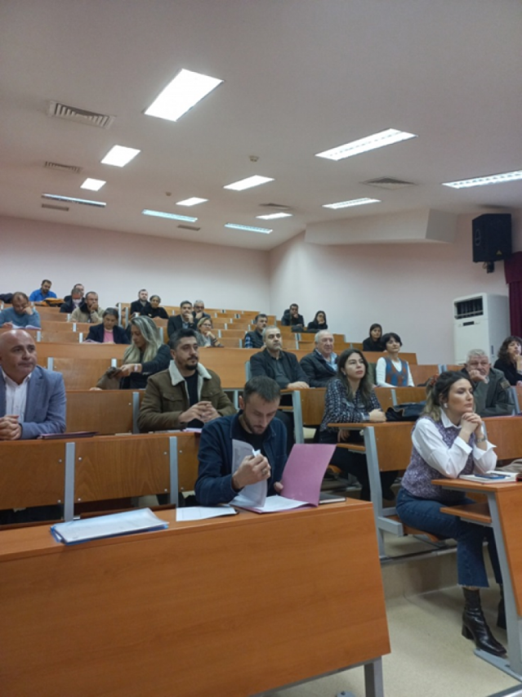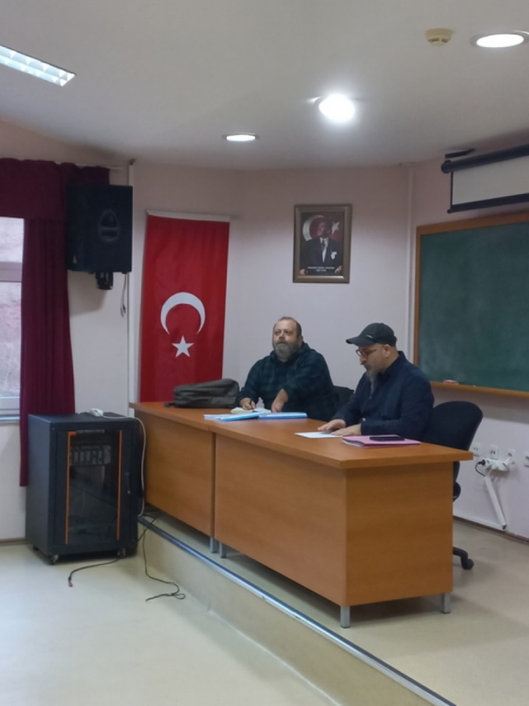
Brochures, posters, etc. prepared within the scope of the event (if any)
Text Prepared for Sharing Purposes:
Regarding accessibility in education, our professors will inform us of any shortcomings in their departments based on the results of orientation programs they conduct, and we will address these issues to the best of our ability. Furthermore, the biggest problem highlighted by all our coordinators is the significant lack of accessibility in the buildings and living spaces on campus. To address this, we will seek support from the University's Construction Department and work to improve the university by preparing reports on all campus buildings and their surroundings. Every individual may have different abilities, but each of these differences has value and beauty. We must work to remove the barriers faced by our disabled students, end discrimination against them, and ensure equal opportunities. While drawing attention to the problems faced by disabled students today, we must also focus on their strengths and achievements.

ACTIVITY: 2
Event Name: Meeting of the Disability Coordination Office and the Erasmus Coordination Office
Event Date and Time: 14.02.2024-14.00
Event Location: Çanakkale Onsekiz Mart University, Erasmus Unit, Faculty of Political Science Building, Ground Floor, 17020, Çanakkale
Event Topic:
Event Program: Meeting of the Disabled Student Unit Coordination Office and the Erasmus Unit Coordination Office of Çanakkale Onsekiz Mart University
Event Objective: To Help All Our Students
Target Audience: Students with Disabilities
Speakers/Participants at the Event: Coordinator of the Unit for Students with Disabilities , Dr. Sinan KALKAN, Coordinator of the Erasmus Unit, Ali Emrah TOKATLIOĞLU

Visual materials (photos and videos) related to the event.
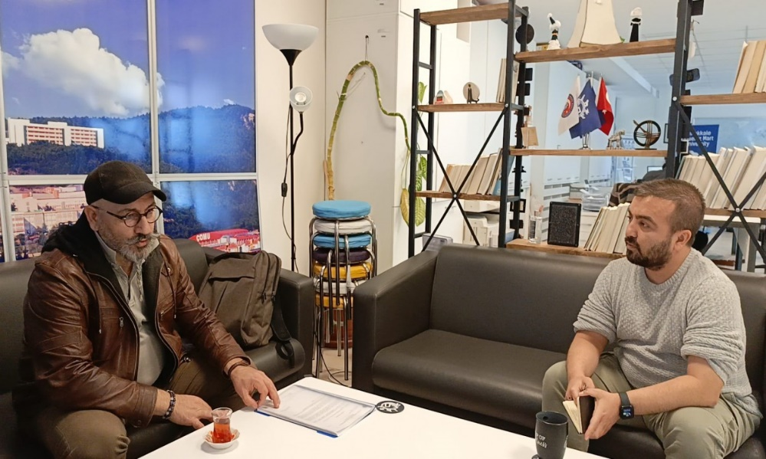
Brochures, posters, etc. prepared within the scope of the event (if any)
Text Prepared for Sharing Purposes:
A short and concise text about the event (maximum 100 words): A meeting was held between Dr. Sinan KALKAN, Coordinator of the Disabled Student Unit at Çanakkale Onsekiz Mart University , and Ali Emrah TOKATLIOĞLU, Coordinator of the Erasmus Unit, to discuss the relationship between the units and the activities and events they have undertaken.
Erasmus Coordinator Ali Emrah TOKATLIOĞLU stated that they assist students at our university in every way, providing information and support. As he himself said, thanks to their open-door policy, they strive to do their best to help all students, not only for Erasmus programs but also in general .
Çanakkale Onsekiz Mart University Erasmus Coordination Office for their new location and hope that their work will be even more successful there.
Information explaining the importance and purpose of the event: It was stated that thanks to their open-door policy, they strive to do their best to help all students, and that they assist students not only for Erasmus but also in general.

ACTIVITY: 3
Event Name: Application for the Accessible University Flag Awards.
Event Date and Time: February 19, 2024
Application dates: January 2, 2024 - February 16, 2024
Event Venue: Çanakkale Onsekiz Mart University
Event Topic: To identify the shortcomings of our faculties and to provide a more accessible environment for our students .
Event Program: Barrier-Free University Flag Awards
Event Objective: To present the Accessible University Flag Awards and the Accessible University Program Badge.
Target Audience: (Included Branches)
Faculty of Dentistry Awarded Orange Flag for Accessibility in its Physical Environment
Accessibility in Education (Green Flag) within the Faculty of Education
State Conservatory Applications have been submitted for the Accessibility in Socio -Cultural Activities (Blue Flag) awards.

Speakers/Participants at the Event:
Barrier-Free Program Award
1-) State Conservatory / Music Department / Vocal Arts Major
Assoc. Prof. Bahadır ÇOKAMAY
Autism Spectrum Disorder
2) State Conservatory / Instrumental Music Department Undergraduate and Graduate Programs
Prof. Dr. Emel Funda TÜRKMEN
Visually Impaired and Autism Spectrum Disorder
3) Faculty of Education / Department of Special Education / Special Education Teacher Training
Dr. Sinan KALKAN, Assistant Professor
Visually impaired
4) State Conservatory / Music Department / Instrumental Music Major
Lecturer Dr. Ayşegül GÖKLEN YILMAZ
Autism Spectrum Disorder
5-) State Conservatory / Music Department / Instrumental Music Major
Lecturer Dr. Ayşegül GÖKLEN YILMAZ
Autism Spectrum Disorder
Visual materials (photos and videos) related to the event:
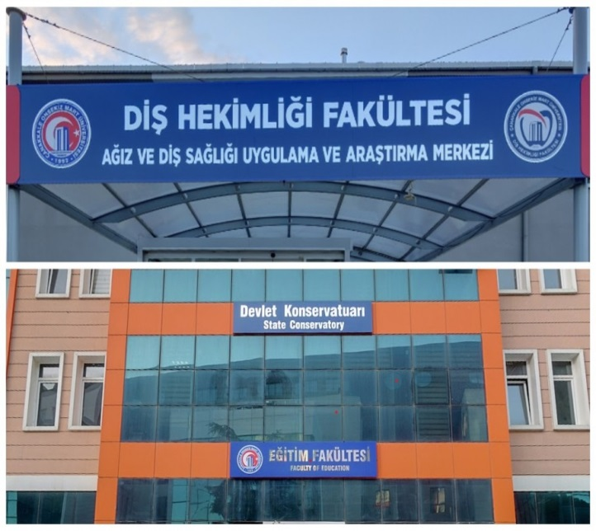
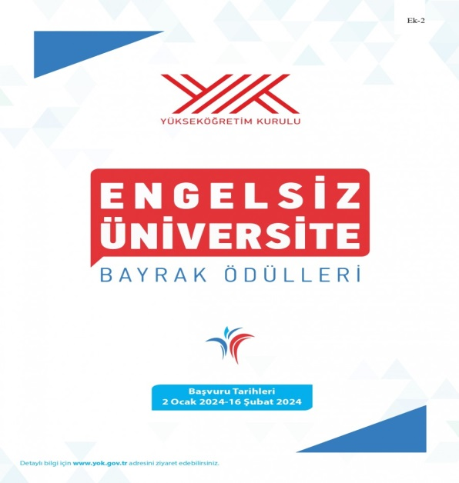
Text Prepared for Sharing Purposes: Çanakkale Onsekiz Mart University has submitted the necessary applications to participate in the Barrier-Free University Flag Awards and Barrier-Free University Program Badge published by the Council of Higher Education . As ÇOMÜ, on this path undertaken under the name of Barrier-Free Access and Barrier-Free Campus, we are making every effort to address the shortcomings of our faculties and to provide a more accessible environment for our students.
Çanakkale As Onsekiz Mart University, we have awarded the Faculty of Dentistry with an Orange Flag for Accessibility in the Physical Environment , the Faculty of Education with a Green Flag for Accessibility in Education, and the State Conservatory. Applications have been submitted for the Accessibility in Socio -Cultural Activities (Blue Flag) awards.
A short and concise text about the event (maximum 100 words): Çanakkale Onsekiz Mart University has completed the necessary registrations to participate in the Barrier-Free University Flag Awards and the Barrier-Free University Program Badge published by the Council of Higher Education .
As ÇOMÜ, on this path we have embarked upon under the name of Barrier-Free Access and Barrier-Free Campus, our faculties are making every effort to address both their shortcomings and to provide a more accessible environment for our students.
Information describing the importance and purpose of the event: To identify the shortcomings of our faculties and to provide a more accessible environment for our students.

ACTIVITY: 4
Event Name: Introduction of the Induction Device by the Çanakkale Onsekiz Mart University Disability Coordination Student Unit
Event Date and Time: February 20 , 2024 - 2:30 PM
Event Venue: Troy Cultural Center
Event Topic: Installation of an Induction Loop System
Event Program:
Activity Objective: Installation of an Induction Loop System
Target Audience: Hearing-impaired students
Speakers/Participants at the Event: Hakan PENBEK, Süleyman ŞAHİN, Engineer Egemen BAYDARIN from the Computer Technical Support Services Unit.
Visual materials (photos and videos) related to the event:
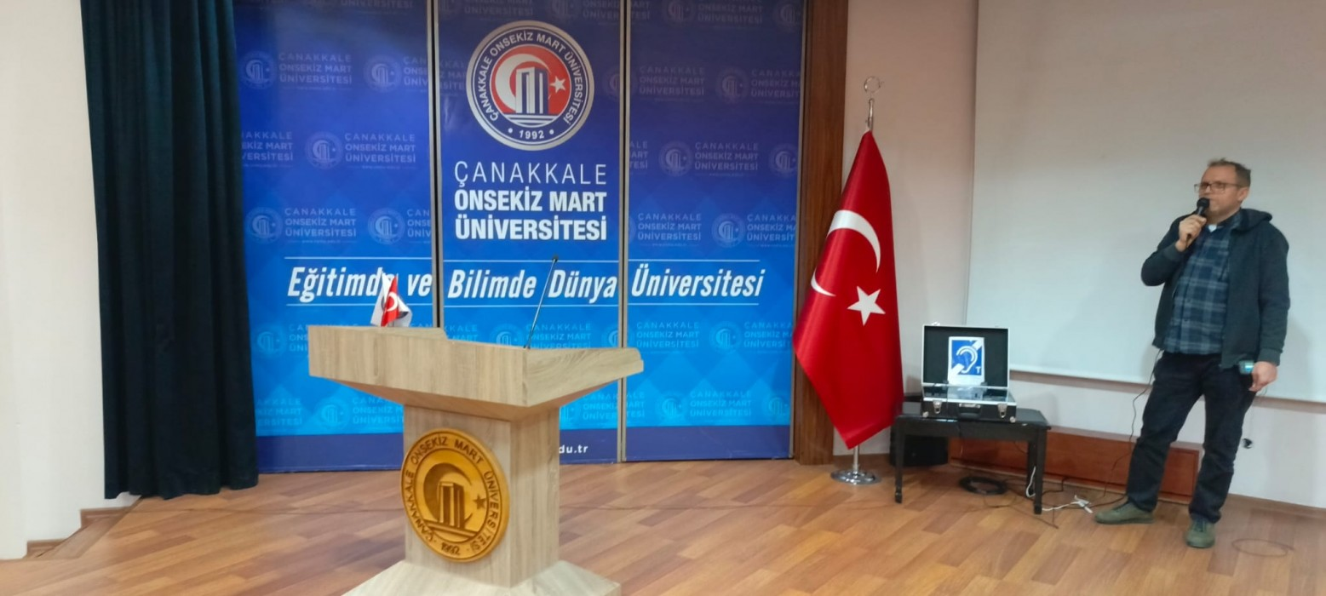
Brochures, posters, etc. prepared within the scope of the event (if any)
Text Prepared for Sharing Purposes: The installation of the Induction Loop System was carried out by the technical service assigned by the Çanakkale Onsekiz Mart University Disability Coordination Student Unit, and tested by Engineer Eğemen BAYDAR from the Computer Technical Support Services Unit of our university staff.
This device, acquired and implemented to make our hearing-impaired students more comfortable in their classes, has been made available for use by all our hearing-impaired students.

ACTIVITY: 5
Event Name: Meeting with Young Turkish Red Crescent Volunteers for a Trip to the Gallipoli Peninsula
Event Date and Time: March 16, 2024 - 10:30 AM
Event Location: Disability Unit Coordination Office
Event Theme: Commemoration of the Martyrs of March 18th and the Çanakkale Naval Victory
Event Program: Tour Program to the Gallipoli Peninsula
Event Purpose: To commemorate the Martyrs of March 18th and the Çanakkale Naval Victory.
Target Audience: Students with disabilities
Speakers/Participants at the Event: Hakan Penbek , Süleyman Şahin, Rabia Işık

Visual materials (photos and videos) related to the event: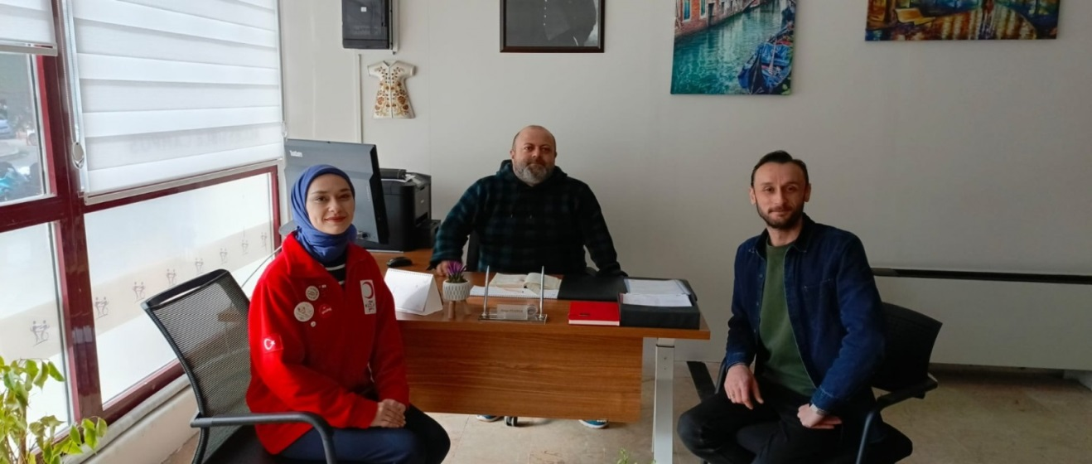
Brochures, posters, etc. prepared within the scope of the event (if any):
Text Prepared for Sharing Purposes:
A short and concise text about the event (maximum 100 words): A meeting was held to discuss a joint trip to the Gallipoli Peninsula Martyrs' Memorials, planned for Saturday, March 16, 2024 , by the Disabled Student Unit Coordination Office of our University and the Çanakkale Young Red Crescent Volunteers of the Turkish Red Crescent Society, as part of the March 18 Martyrs' Commemoration Day and Çanakkale Naval Victory commemoration events.
Information explaining the importance and purpose of the event: It is held as part of the commemorations of the Martyrs of March 18th and the Çanakkale Naval Victory.

ACTIVITY: 6
Event Name: Gallipoli Peninsula Martyrs' Memorial Tour
Event Date and Time: March 23, 2024, 8:30 AM
Event Location: Historical Sites of the Gallipoli Peninsula
Event Topic: A field trip program for our university's disabled students as part of the commemorations of the March 18 Martyrs' Day and the Çanakkale Naval Victory.
Event Program:
- 08:30 Gathering at Cumhuriyet Square (near the cannon).
- At 09:00, vehicles will board the Eceabat ferry.
- The Gallipoli Peninsula Martyrs' Memorial tour will begin at 09:45 .
- 13:00 – 14:00 Lunch in Alçıtepe Village .
- Return on the 17:00 Eceabat ferry.

Event Purpose: 1. To commemorate the Martyrs of March 8th and the Çanakkale Naval Victory.
Target Audience: Students with Disabilities
Speakers/Participants at the Event: Mürvet DEMİRTAŞ, Erkut KÖSE, Kübra ÖZ, Habibe YILDIZ, Şaban ÖZBAY, Ahmet Eren ÇAVUŞ, Emine Melek ŞAŞMAZ, Melis MUTLU, Fatma ZENGİN SONGÖZ, Nagihan KEKEÇ, Kadir PARLAK, Fatih ŞEKER, Hakan PENBEK, Süleyman ŞAHİN, Sinem VURAL and Turkish Red Crescent Volunteers

Visual materials (photos and videos) related to the event.
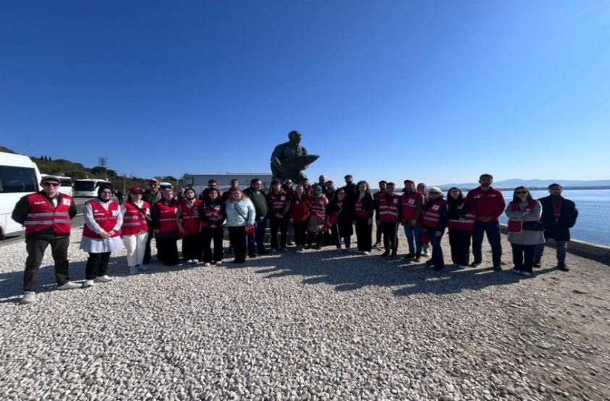
Brochures, posters, etc. prepared within the scope of the event (if any)
Text Prepared for Sharing Purposes: As part of the March 18th Martyrs' Day and Çanakkale Naval Victory commemoration events, jointly organized by the Çanakkale Onsekiz Mart University Disabled Student Unit Coordination and the Çanakkale Young Red Crescent community, a trip to the Gallipoli Peninsula Martyrs' Memorial was organized for our university's disabled students on Saturday, March 23, 2024. We would like to thank our guide who, with great emotion , explained and brought to life the historical sites and events that took place in history. We remember with gratitude and respect all our martyrs and veterans, especially the Great Leader Mustafa Kemal Atatürk and his comrades-in-arms, who enabled us to live and thrive freely in this beautiful country today.

ACTIVITY: 7
Event Name: Child Health Conference
Event Date and Time: Saturday, March 9, 2024, 18:00
Event Location: Germany
Activity Topic: Supporting children's socio-emotional development and preventing potentially problematic behaviors.
Event Program: Dr. Sinan KALKAN, Assistant Professor , will provide valuable information on the event. The event will be held in both Turkish and German.
Brochures, posters, etc. prepared within the scope of the event (if any):
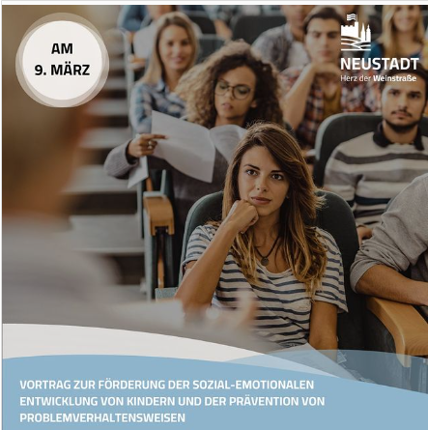

ACTIVITY: 8
Event Name: Beyond Barriers
Event Date and Time: Thursday, March 28, 2024 at 13:10
Event Venue: 📻radyo.comu.edu.tr
📻FM104.7
Event Topic: Discussing the importance of special education for individuals with special needs to live independently, its activities, individualized education, and campus life.
Event Program: The program, prepared and presented by Naile ERDEM, will feature a question-and-answer session with guest speaker Dr. Sinan KALKAN .
Brochures, posters, etc. prepared within the scope of the event (if any):
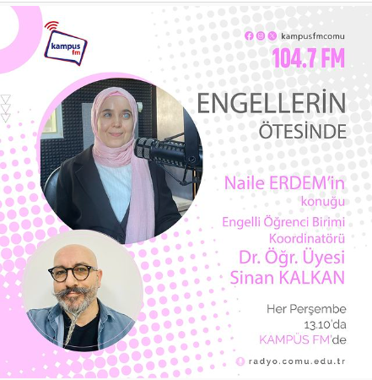

ACTIVITY: 9
Event Name: A Braille alphabet printer has been provided to the Disabled Student Unit Coordination Office.
Event Date and Time: Wednesday, May 8, 2024, at 10:30 AM
Event Location: Disabled Student Unit Coordination Office
Event Topic: Acquiring a Braille Alphabet Printer for the Disabled Student Unit Coordination Office
Brochures, posters, etc. prepared within the scope of the event (if any):

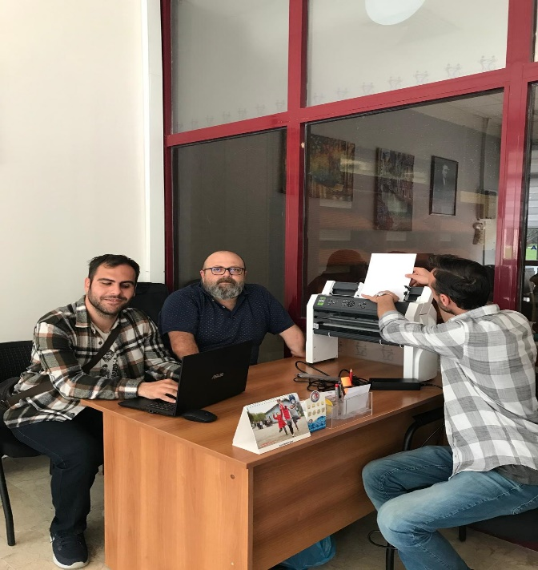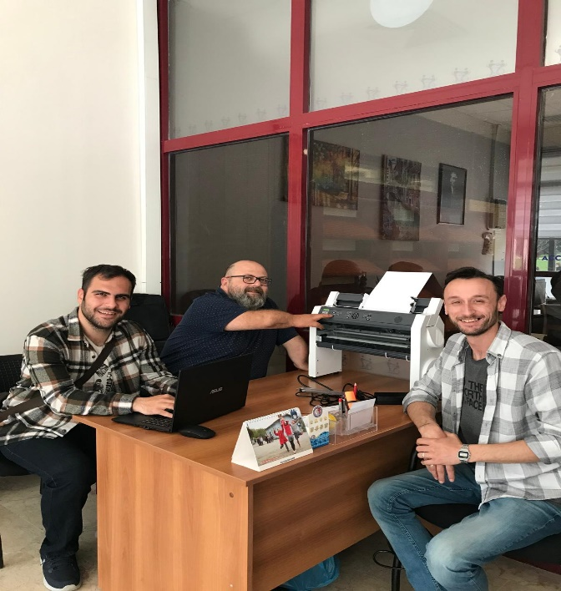
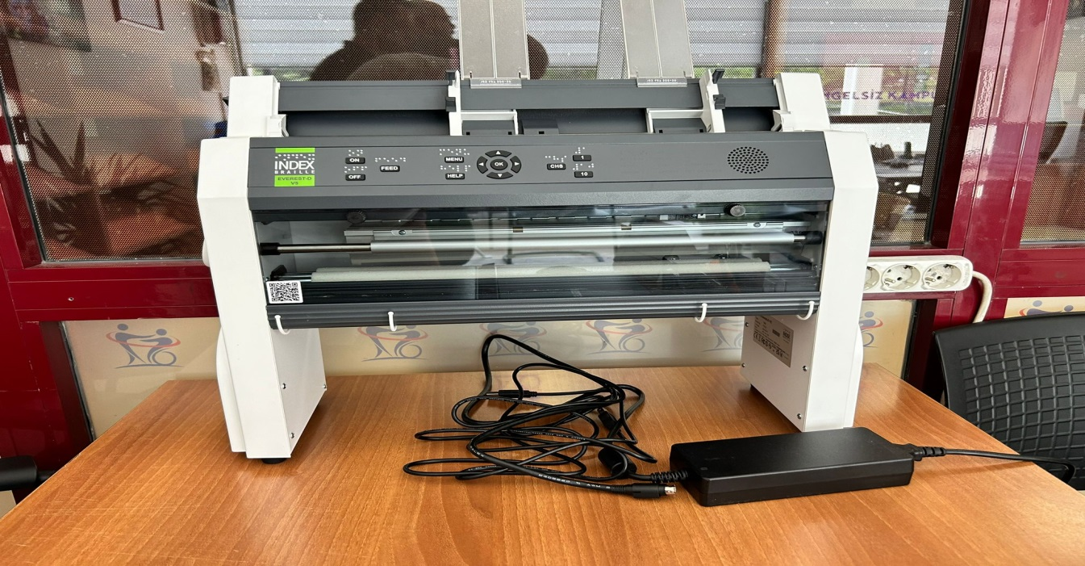

ACTIVITY: 10
Event Name: Çanakkale Onsekiz Mart University Disability Coordination Student Unit 2 - Acquisition and Introduction of 2 More Induction Devices
Event Date and Time: Wednesday, May 8, 2024 at 2:30 PM
Event Location: Troya Cultural Center and ÇOMÜ Disabled Student Coordination Unit
Event Topic: Installation of an Induction Loop System
Event Program:
Activity Objective: Installation of an Induction Loop System
Target Audience: Hearing-impaired students
Speakers/Participants at the Event: Hakan PENBEK, Süleyman ŞAHİN, Engineer Egemen BAYDARIN from the Computer Technical Support Services Unit.
Visual materials (photos and videos) related to the event:
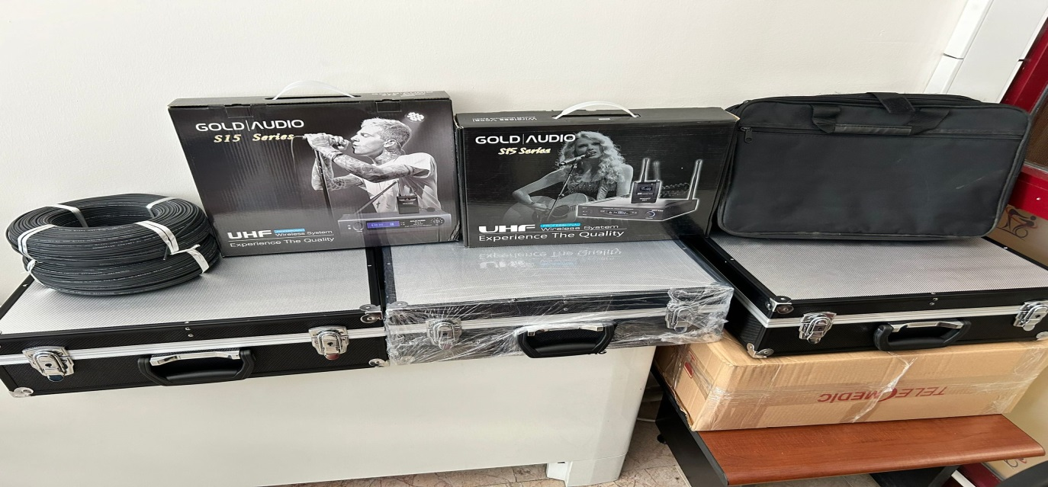
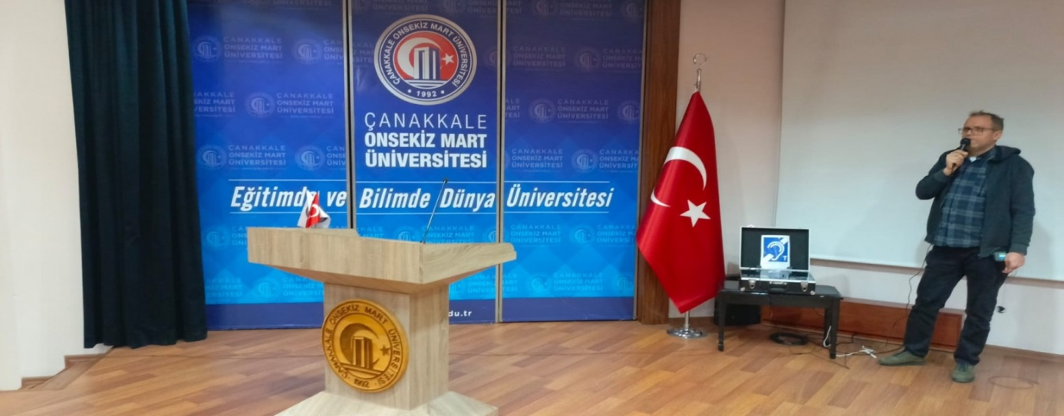
Brochures, posters, etc. prepared within the scope of the event (if any)
Text Prepared for Sharing Purposes: The installation of the Induction Loop System was carried out by the technical service assigned by the Çanakkale Onsekiz Mart University Disability Coordination Student Unit, and tested by Engineer Egemen BAYDAR from the University's Computer Technical Support Services Unit.
This device, acquired and implemented to make our hearing-impaired students more comfortable in their classes, has been made available for use by all our hearing-impaired students.

ACTIVITY: 11
Event Name: Radio Program Titled "Beyond Barriers" Organized by the Çanakkale Onsekiz Mart University Disability Coordination Student Unit During Disability Week, May 10-16, 2024
Event Date and Time: Thursday, May 16, 2024 at 13:10
Event Location: ÖSEM Building, Efem Campus, ÇÖMÜ - radio.comu.edu.tr - FM104.7
Event Topic: Radio Program “Beyond Barriers”
Event Program: Events held as part of the Disability Awareness Week Programs, May 10-16, 2024 .
Event Objective: To raise awareness about the difficulties faced by students with disabilities, what needs to be done, etc.
Target Audience: All students with disabilities studying at our university.
Speakers/Participants at the Event: Assoc. Prof. Dr. Yah Han ERBAŞ, Specialist Psychologist Serdal TOPAL
Visual materials (photos and videos) related to the event:
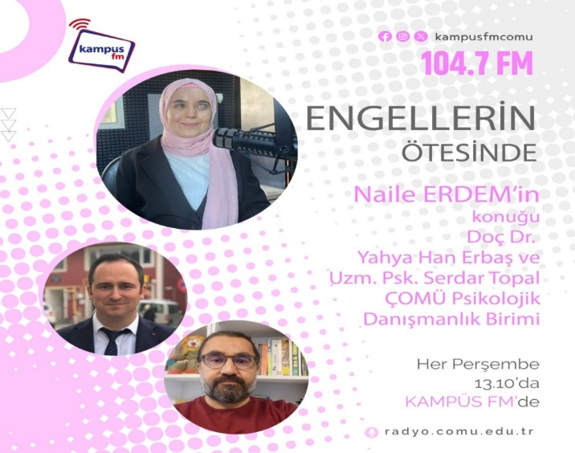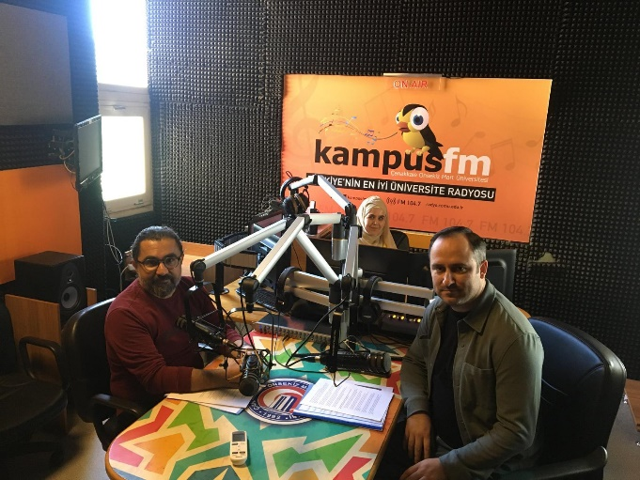

ACTIVITY: 12
Event Name: Çanakkale Onsekiz Mart University Disability Coordination Student Unit's Campus Special TV Program for Disability Week, May 10-16, 2024
Event Date and Time: Tuesday, May 14, 2024 at 11:30 AM (Filming Date)
Release Date: Friday, May 17, 2024, 5:00 PM
Event Location: ÖSEM Building, Efem ÇÖMÜ TV Campus
Event Topic: Disability Awareness Week Campus Special TV Program
Event Program: Events held as part of the Disability Awareness Week Programs, May 10-16, 2024 .
Event Objective: To raise awareness about the difficulties faced by students with disabilities, what needs to be done, etc.
Target Audience: All students with disabilities studying at our university.
Speakers/Participants at the Event: Dr. Sinan KALKAN
Visual materials (photos and videos) related to the event:

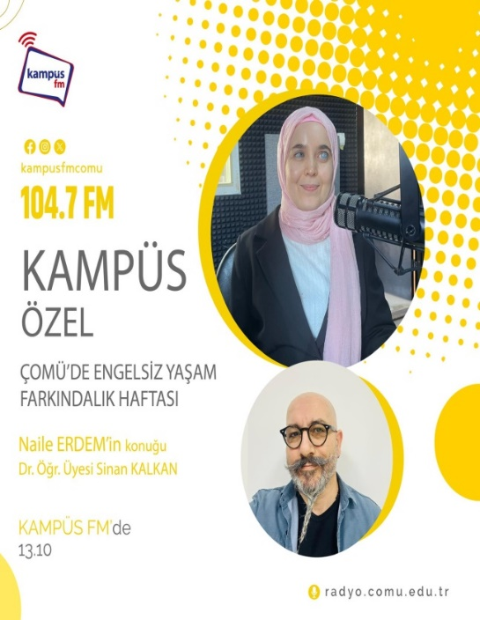
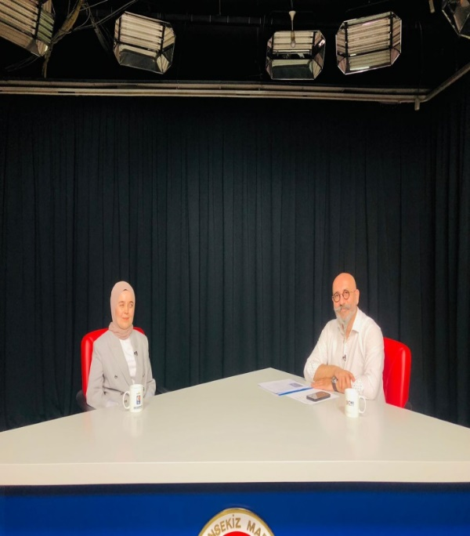

- ASSESSMENT OF INSTITUTIONAL CAPABILITY AND CAPACITY
A- Advantages
The Unit for Students with Disabilities is a unit that anticipates the needs for inclusive education before they arise and develops its work accordingly.

B- Weaknesses
The unit's scope of activity is very broad due to the diversity of its areas of interest, but there is insufficient budget to carry out the designated activities.

C-Evaluation
Although there have been successful and even exemplary projects, the individual -based approach to unit activities poses a risk to continuity and institutional memory. If we also consider the need to maintain highly efficient projects, creating horizontal expansions within the organizational chart and implementing systematization arrangements will be beneficial in the long run.

- RECOMMENDATIONS AND MEASURES
Based on a priority list, an optimistic estimate suggests that either half of the planned accessibility improvements can be implemented, or a budget revision may be necessary to complete them all.

