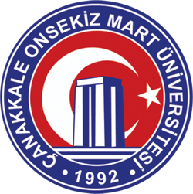

ÇANAKKALE ONSEKIZ MART

UNIVERSITY

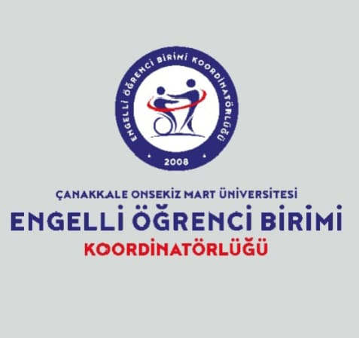

DISABLED STUDENT UNIT COORDINATORSHIP

2025 ANNUAL ACTIVITY REPORT

- Executive Presentation

Our activity report for 2025, as the unit coordinator, is presented here. Within the framework of our unit's mission and vision, plans for 2026 have been made, and our improvement efforts for students with special needs studying at our university continue.

Assoc. Prof. Dr. Sinan KALKAN
Coordinator

- Aim

Our main goal is to create equal opportunities for disabled individuals studying at our university to participate in academic and social life, and to transform our campus into an accessible living space with its physical, academic, and social facilities. Creating an accessible university within our university will enable all individuals with special learning needs to actively work and live within this campus, providing them with a significant source of inspiration for productive, innovative individuals, or those who have closed themselves off to innovation. The 'Accessible Office' will be a center aimed at eliminating the obstacles that our disabled students face in their academic, social, and cultural lives, and enabling them to take a more active role in university life and increase their success. In this center, counseling, guidance, and support services will be provided to our students with special needs.

- Scope
the activities and services of the "Disabled Student Unit" established under the Rectorate of Çanakkale Onsekiz Mart University, as well as the instructional arrangements and examination adaptations to be made for students with special needs affected by disabilities.

- Çanakkale Onsekiz Mart University

Established on July 3, 1992, by Law No. 3837, Çanakkale Onsekiz Mart University began its educational activities in the 1992-1993 academic year with the Faculty of Education, Çanakkale Vocational School, and Biga Vocational School, which were transferred from Trakya University . Our university comprises a Graduate Education Institute, 21 Faculties, 3 Schools, and 13 Vocational Schools, totaling 37 educational units under one roof. It also has 37 Research and Application Centers.

- Our University's Mission, Vision, Core Values, Aims and Objectives

- Mission

Our mission is to cultivate competent individuals through a contemporary, sustainable, and inclusive educational approach; and to contribute to society at national and international levels through the scientific knowledge and technologies we produce, as well as the cultural, sporting, and artistic activities we carry out.

Vision

To be a leading university in science, technology, art, sports, and culture, contributing to the quality of life of society by nurturing innovative and entrepreneurial individuals.

- Core Values

Çanakkale Onsekiz Mart University, with all the achievements it has gained since its establishment within its valuable geographical location, is progressing towards becoming a university of high values. These values are:

- Justice and Merit
- Academic Competence
- Corporate Belonging and Participation
- Commitment to Ethical Values
- Entrepreneurship, Innovation and Creativity
- Commitment to National and Spiritual Values
- Inclusive Education Approach

- Aims and Objectives

- To create added value at national and international levels through high-quality R&D and product development activities.
- To Sustainably Improve the Quality of Education and Training Activities
- To increase the university's activities for the benefit of society and the environment.
- Increasing the International Recognition of Our University
- Strengthening Quality Culture and Corporate Resources

- Unit Introduction (History, etc.)

The Disabled Student Unit Coordination Office was established in the 2008-2009 academic year and began its operations in the same year. Since its inception, it has followed the principle of ensuring that students with special needs studying at our university can benefit to the fullest extent from our social areas and learning processes.

- Unit Mission, Vision and Core Values

Mission

Our aim is to ensure that the indoor and outdoor spaces of our university campus are accessible and usable for our disabled students, to identify the problems faced by disabled individuals studying at our university and to develop solutions, to ensure the participation and support of disabled individuals in social, cultural and sports activities, to make the education, teaching and examination environments suitable for disabled individuals, and to raise awareness about disability and barriers.
Vision

Our goals are to ensure equal access to university facilities and social services for students with special needs, to create a supportive environment for their development, to identify the needs and challenges faced by students with disabilities in various areas during their studies and to provide services to meet these needs, and to develop support services for faculty members regarding the physical, academic, and social support that students with disabilities require.

Core Values

Our coordination office conducts its activities in accordance with the core values outlined below.

- Respect
- Accessibility
- Security
- Tolerance
- Commitment to ethical values
- Continuous improvement
- Social responsibility
- Communication with internal and external stakeholders

- Unit Stakeholder Analysis
The internal stakeholders of the Disabled Student Unit Coordination Office include students, academic and administrative staff, relevant faculties, colleges, application and research centers within the university, and other coordination offices.
External stakeholders include official and private institutions and organizations located in Çanakkale, relevant ministries, the disability student coordination units of universities, and civil society organizations.
- Unit Condition Analysis Physical Structure
The Disabled Student Unit Coordination Office is located in the building at Çanakkale Onsekiz Mart University, Terzioğlu Campus, Central Library Ground Floor. The Coordinator represents the unit and reports directly to the Rector. Disabled Student Coordinators in academic units, along with deans/deputy directors providing administrative support, are responsible to the Disabled Student Unit according to the Disabled Student Unit Regulations. The unit has a management board and a quality committee.

- Academic Infrastructure

  - Academic Staff Distribution

- Unit Commission Members
Years | Prof. | Associate Professor | Assistant Professor (Dr.) | Lecturer​ | Research Assistant | Total
2025 | 2 | 2 | 2 | 0 | 1 | 7

- Disability Unit Coordinators
Years | Prof. | Associate Professor | Assistant Professor (Dr.) | Lecturer​ | Research Assistant | Total
2025 | 2 | 8 | 8 | 15 | 4 | 37

- Administrative Infrastructure
Disabled student coordination office and staff
ORGANIZATIONAL STRUCTURE

- Physical Infrastructure and Facilities

  - Technological Infrastructure
Gender | For Administrative Purposes  (Piece) | For Educational Purposes (Quantity) | For Research Purposes (Quantity)
Projection |  | 1
Induction Device |  | 1
Printer | 1
Copying machine | 0

Computer Numbers
Type | Piece
Number of desktop computers | 2
Number of portable computers | 1
Total | 3

- SWOT Analysis
Strengths
- Having an innovative and peaceful working environment,
- Having a young and dynamic academic staff,
- Having good communication with other units of the university,
- The presence of cultural diversity at Çanakkale Onsekiz Mart University.
Weaknesses
- Faculty members have difficulty allocating time to unit coordination activities due to their heavy teaching workloads.
- The fact that our university campuses are located in different places,
- Insufficient physical space for the coordination office,
- Insufficient level of relations with external stakeholders.
Opportunities
- The existence of ongoing efforts to continuously improve physical infrastructure for people with disabilities,
- Providing opportunities for disabled students in education, health, sports, scientific and socio-cultural activities,
- The region should have the resources to conduct research on its environmental and cultural values.
Threats
- Low number of staff in the unit
- Some students with disabilities have a weak sense of belonging and acceptance at school.

- Strategy Development

  - Aims and Objectives

To ensure that our disabled students in the faculty receive a more accessible and proper education and obtain course materials much more quickly.

- Monitoring and Evaluation
The work to be carried out to achieve the aims and objectives stated in the plan will be systematically monitored and evaluated. Based on the results of this evaluation, the status of the achievement of the aims and objectives stated in the strategic goals and indicators, in line with the mission , vision, and core values of our Coordination Office, will be reported. The prepared reports will be published on the Coordination Office's website. The strategic goals and indicators plan includes the timelines for achieving the aims and objectives of the Coordination Office and the resources that should be used.
To assess the progress of strategic objectives, the first step will be to analyze the extent to which the planned activities have achieved their aims and objectives. Following this, the percentage of activities that have been completed will be examined.
Following these reviews and evaluations, if there are no significant internal or external changes in our department, if strategies and activities are being implemented as planned, and if progress towards achieving objectives is positive, the implementation of strategic goals and indicators will continue. If goals are not achieved, an investigation will be conducted to determine the cause. After identifying the reasons for the shortcomings, corrective and preventive measures will be taken for individual and departmental deficiencies. For outcomes caused by uncontrollable factors outside the department, the goals will be revised.

18. Performance Indicators and Strategies
Objective A.1. To Increase Student Success Through Student-Centered Education
Objective H. 1.1 . Accessibility for students with disabilities in physical, educational and social areas will be increased.
 | To the target  Its effect  (%) | Plan Initial Value | Target 2024 | 2025  Aim | 2026  Aim | Target 2027 | 2028  Aim
PG 1.1.1. Level of physical accessibility for people with disabilities within the campus (%) | 20 | 30 | 50 | 70 | 80 | 90 | 100
PG 1.1.2. Satisfaction level of disabled people with university services (%) | 30 | 50 | 70 | 80 | 90 | 100 | 100
PG 1.1.3. Level of accessibility to university education for people with disabilities (%) | 30 | 40 | 50 | 70 | 90 | 100 | 100
PG 1.1.4. Number of all types of social, cultural, sporting and educational activities related to people with disabilities. | 20 | 2 | 10 | 15 | 20 | 25 | 30
Strategies

*Should be increased according to the number of aims and objectives.

ACTIVITY: 1
Event Name: Embedded Instruction Methods Practitioner Certification Program
Event Date and Time: January 29, 2025 , 10:00 AM
Event Venue: Atatürk Youth Center Conference Hall, Edremit / Balıkesir
Topic: Embedded Instruction Method
Event Program: Practitioner Certification Program
Activity Objective: Embedded instruction is a natural teaching method that aims to help teachers determine what to teach, when to teach, how to teach, and how to evaluate their instruction, and to provide children with learning experiences accordingly.
Target group:
- Special Education Teachers
- Preschool Teachers
- Child Development Specialists
- Other Educators and Therapists Working with Children

Speakers/Participants at the Event: Coordinator of the Unit for Students with Disabilities, Dr. Assoc . Prof. Sinan KALKAN
Visual materials (photos and videos) related to the event.
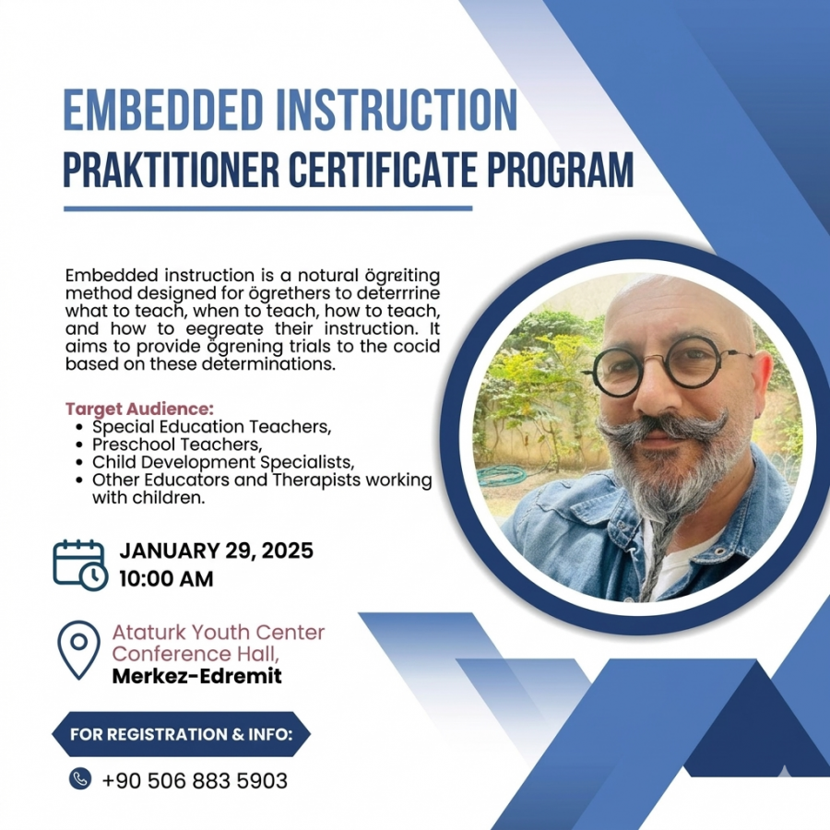

ACTIVITY: 2
Event Name: EARLY INTERVENTION PROGRAM, Practitioner Certification Program
Event Date and Time: January 30-31, 2025, 09:00 - 13:00
Event Venue: Atatürk Youth Center Conference Hall, Edremit / Balıkesir
Event Topic: Early Intervention Program
Event Program: Practitioner Certification Program
Event Objective: The program was a seminar demonstrating the vital importance of early intervention.
Speakers/Participants at the Event: Coordinator of the Unit for Students with Disabilities , Dr. Assoc. Prof. Sinan KALKAN
Visual materials (photos and videos) related to the event.
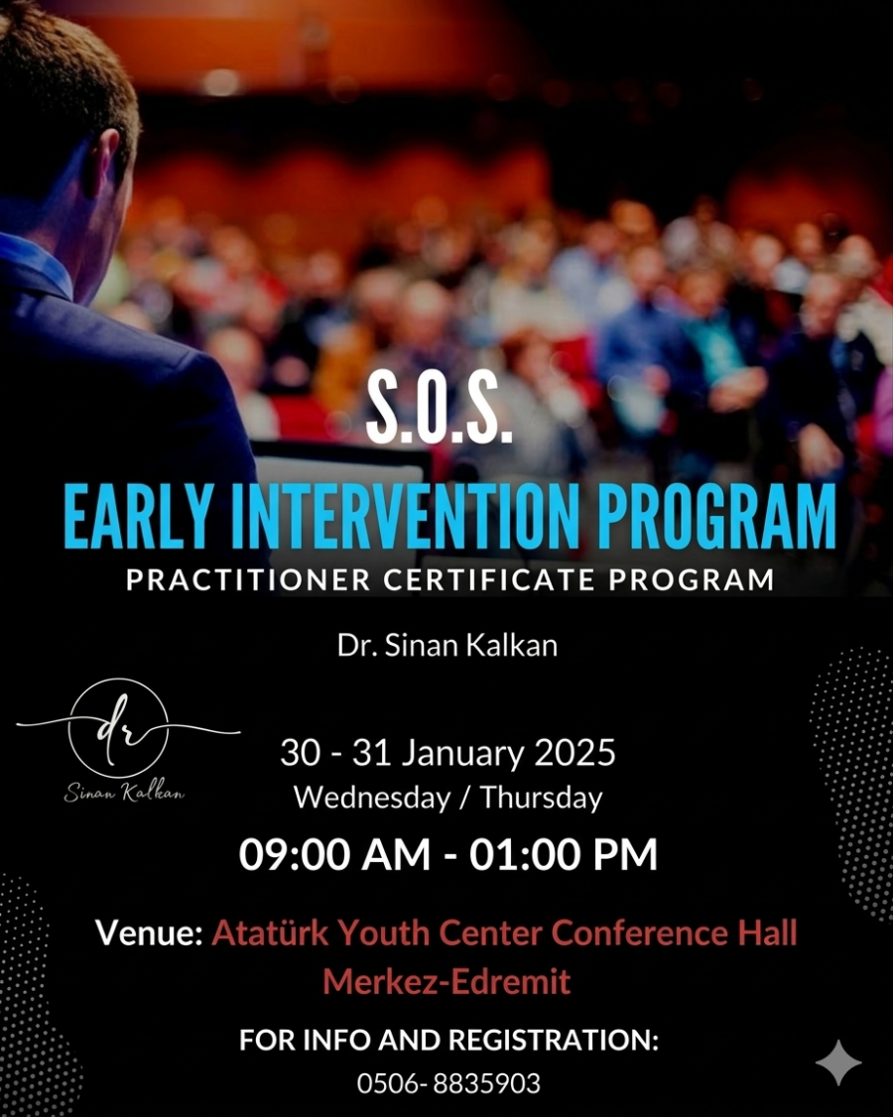

ACTIVITY: 3
Event Name: Early Intervention Program, Practitioner Certification Program
Event Date and Time: March 9, 2025, 10:00 AM
Event Location: Derin Private Child Special Education and Rehabilitation Center, Bağcılar/Istanbul
Event Topic: Early Intervention Program
Event Program: Practitioner Certification Program
Event Objective: The program was a seminar demonstrating the vital importance of early intervention.
Speakers/Participants at the Event: Coordinator of the Unit for Students with Disabilities , Dr. Assoc. Prof. Sinan KALKAN
Visual materials (photos and videos) related to the event:
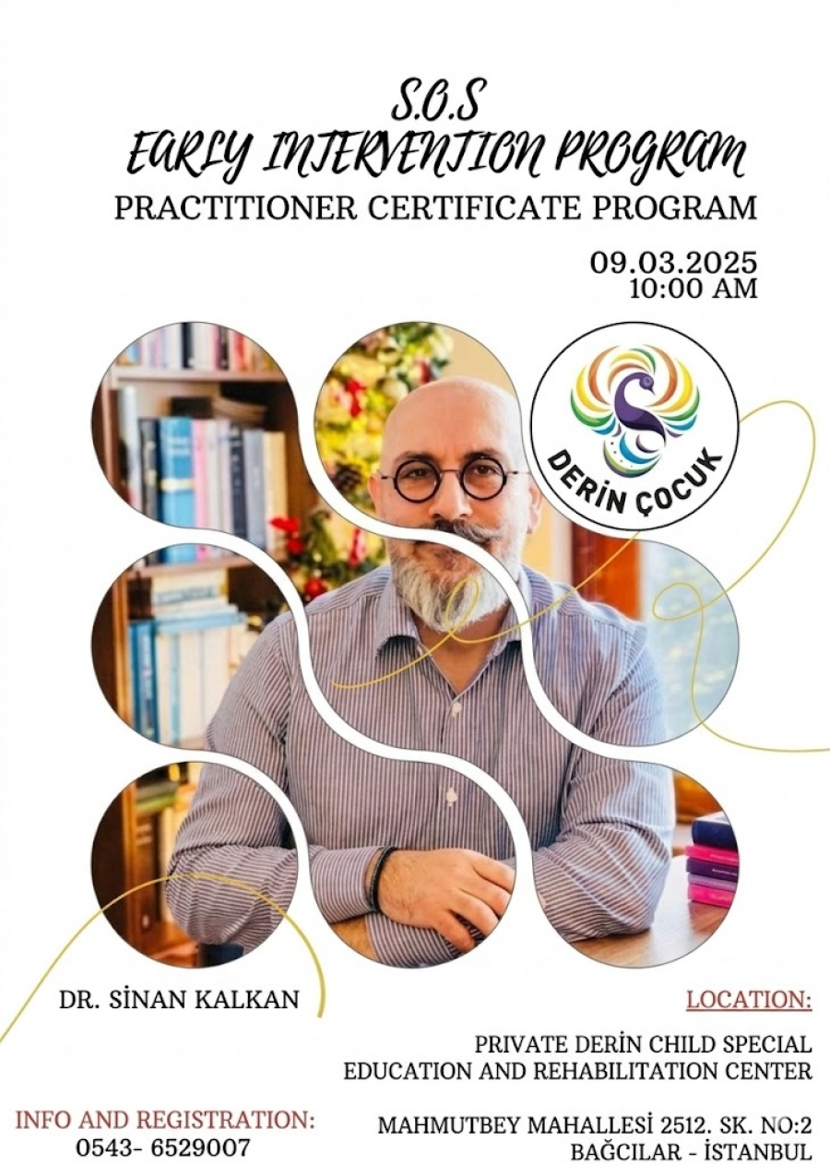

ACTIVITY: 4
Event Name: Connecting Forces in Development / Workshop
Event Date and Time: April 24-27, 2025
Event Location: Anadolu University Student Center
Event Topic: Working with Families from Diagnosis to Intervention in Early Childhood
Event Program: 8th International National Interdisciplinary Congress on Early Childhood Intervention
Purpose of the Event:
To enable experts from different disciplines, who have been providing services to children aged 0-6/8 with developmental differences or at risk and their families in our country for years, to establish a common language.
To introduce early intervention processes and practices in other countries to our country's field experts through international participants.
a platform for experts from different disciplines in the field of early childhood intervention in our country to share their work in a scientific context .
The aim is to provide training on existing early childhood intervention practices (such as programs and assessment tools) in our country.
Target Audience: Experts, researchers, practitioners, families, students, and politicians in the field.
Speakers/Participants at the Event: Coordinator of the Unit for Students with Disabilities, Dr. Assoc . Prof. Sinan KALKAN
Visual materials (photos and videos) related to the event:
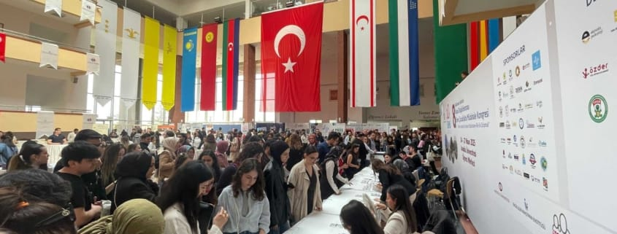

ACTIVITY: 5
Event Name: May 10-16 Disability Awareness Week
Event Date and Time: May 12, 2025, 1:00 PM
Event Venue: Hasan Mevsuf Sports Hall
Event Topic: Goal Ball awareness competition
Event Program: Goalball Competition
Event Objective: Çanakkale Onsekiz Mart University organized this goalball event to demonstrate that their focus isn't solely on the education of disabled students .
Target Audience: Visually Impaired Students
Speakers/Participants at the event included: ÇOMÜ Vice Rector Prof. Dr. Arda Aydın, İŞKUR Provincial Director Mehmet Uğur Yavuz, Sports Association Coordinator Dr. Deniz Ünver, 1915 Çanakkale Visually Impaired Sports Club President Nuray Işık Telli, Çanakkale Provincial Representative for the Visually Impaired Akif Telli , as well as athletes from the 1915 Çanakkale Sports Club, academics, ÇOMÜ administrators, and students.
Visual materials (photos and videos) related to the event:
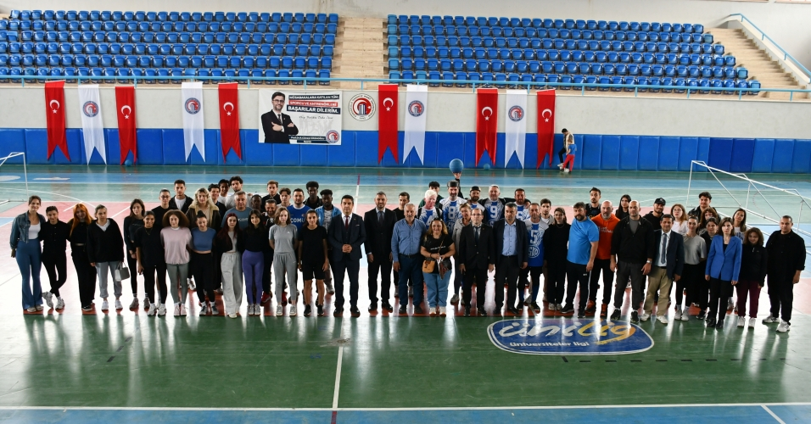
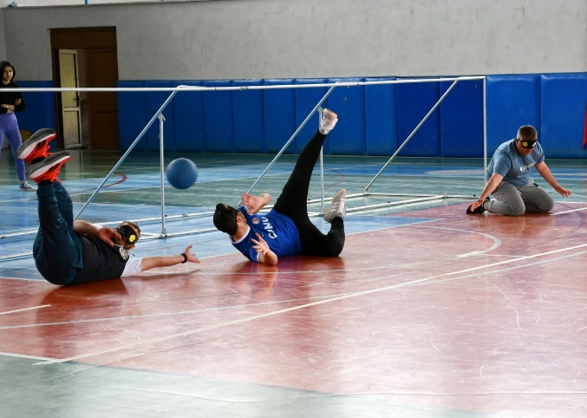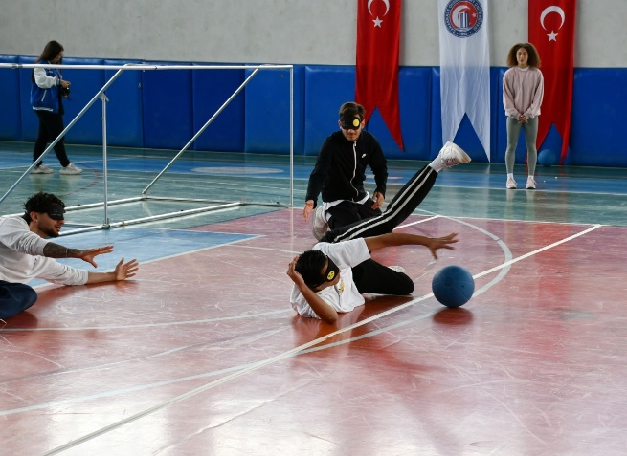

ACTIVITY: 6
Event Name: 5th Autism and Music Summer School
Event Date and Time: July 4, 2025, 8:30 PM
Event Location: Online Zoom
Event Topic: The relationship between autistic individuals and music.
Event Objective: The event, organized via Zoom by OMYO Autism and Music Summer School and featuring Dr. Sinan KALKANI, focused on the relationship between autistic individuals and music, the unifying power of music, and what autistic individuals can achieve when given the opportunity .
Target Audience: Individuals with Autism
Speakers/Participants at the Event: Dr. Sinan KALKAN , Coordinator of the Unit for Students with Disabilities .
Visual materials (photos and videos) related to the event.
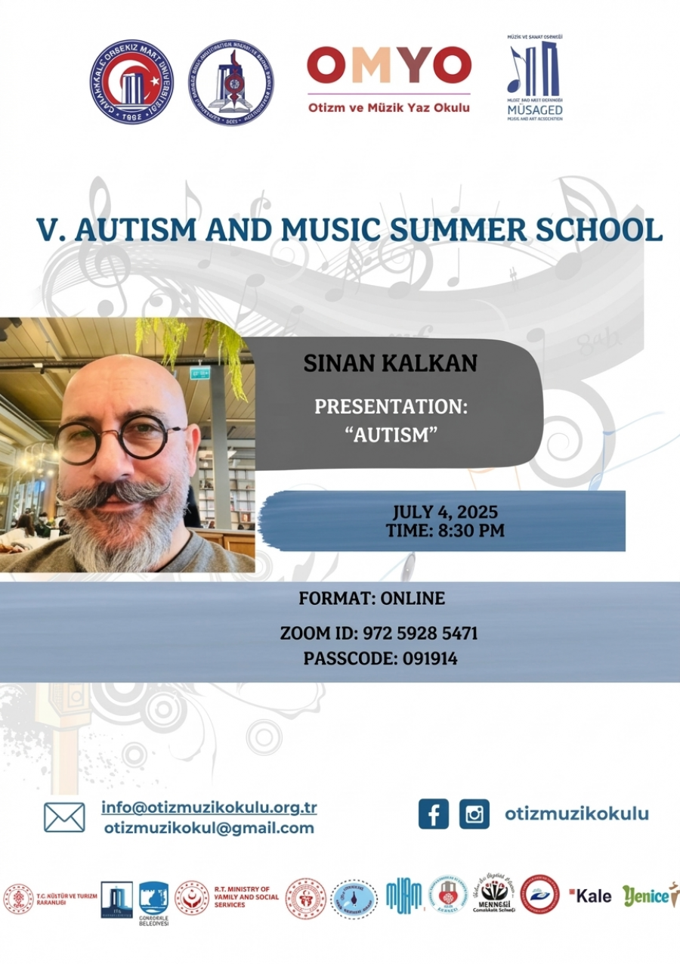

ACTIVITY: 7
Event Name: Installation of Induction Device at Ezine Food Specialization Organized Industrial Zone Vocational School
Event Date and Time: October 16, 2025, 10:00 AM
Event Location: Ezine Food Specialization Organized Industrial Zone Vocational School
Event Topic: Induction device installation.
Purpose of the Activity: An induction device was installed to facilitate listening to the lesson for a student with hearing impairment.
Speakers/Participants at the Event: Hakan PENBEK, Süleyman ŞAHİN,
Brochures, posters, etc. prepared within the scope of the event (if any):
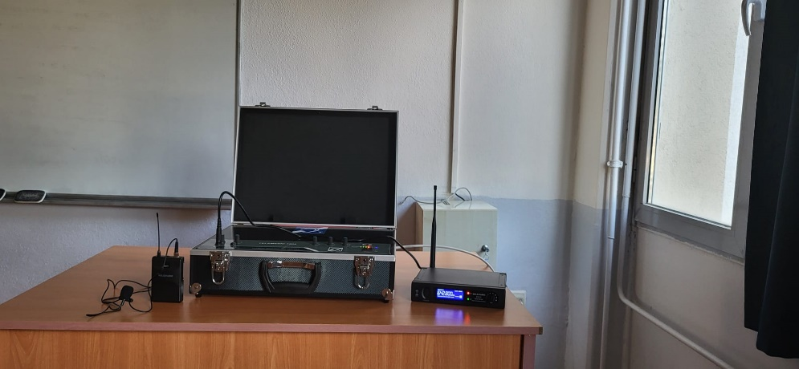
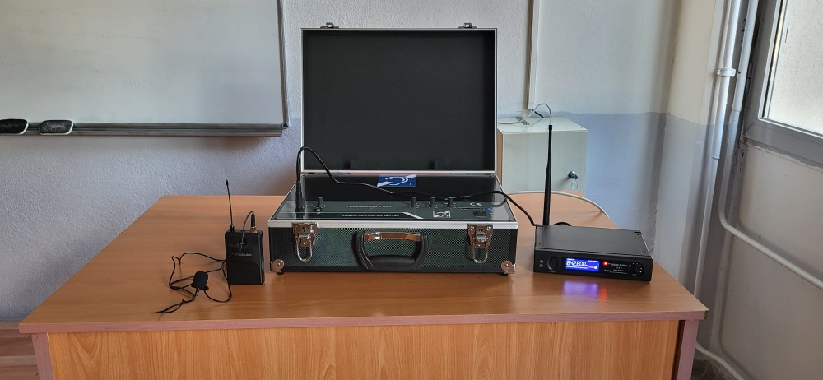

ACTIVITY: 8
Event Name: Orientation Meeting of the Disabled Student Unit Coordination Office
Event Date and Time: November 17, 2025, 10:00 AM
Event Venue: Troia Cultural Center
Event Topic: An information meeting for the coordinators of the disability student units in the faculties of our university.
Event Program: Psychologist Serdar TOPAL, who spoke as a participant in the meeting, addressed the Disability Unit Coordinator, Dr. Assoc . Prof. Sinan KALKAN. The meeting was moderated by [moderator 's name]. Following the meeting, with the participation of our professors, necessary information was provided in a question-and-answer session to address any shortcomings.
Event Objective: An information meeting was held to inform participants about how to communicate with students with disabilities, the importance of accessibility in teaching materials, and the psychological approach to be taken.
Target Audience: Coordinators of the Student Disability Unit and Students with Disabilities
Speakers/Participants at the Event: Hakan PENBEK, Süleyman ŞAHİN, Psychologist Serdar TOPAL, Disability Unit Coordinator Dr. Assoc . Prof. Sinan KALKAN, Disability Student Unit Coordinators.
Brochures, posters, etc. prepared within the scope of the event (if any):

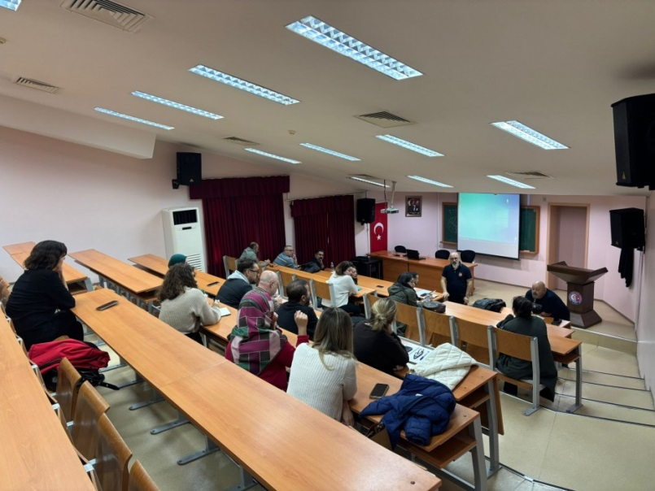

ACTIVITY: 9
Event Name: Meeting on Planning Educational Services for Students with Disabilities
Event Date and Time: November 17, 2025, 13:00
Event Location: Troia Cultural Center
Event Topic: Planning Educational Services for Students with Disabilities
Event Program: Dr. Sinan KALKAN, Assistant Professor During the meeting, moderated by [moderator's name] , the importance of how disabled students should behave in their working lives after school and the need for us to prioritize love, respect, and empathy towards disabled individuals were emphasized. Psychologist Serdar TOPAL then spoke, describing the problems and difficulties faced by disabled students and individuals in school and work life. He concluded by saying that he was confident that by approaching disabled individuals with a gentle and patient attitude, we could create a more livable environment for everyone.
Our Vice Rector, Prof. Dr. Arda AYDIN, took the floor at our meeting on Planning Educational Services for Students with Disabilities and stated that he, on behalf of our university, is doing his best to provide necessary support to students and individuals with disabilities in education, and that a more favorable and accessible environment will be offered in the coming periods, and that the necessary work will be carried out.
Target Audience: Coordinators of the Student Disability Unit and Students with Disabilities
Speakers/Participants at the Event: Hakan PENBEK, Süleyman ŞAHİN, Psychologist Serdar TOPAL, Disability Unit Coordinator Dr. Assoc . Prof. Sinan KALKAN, Disability Student Unit Coordinators, Vice Rector Prof. Dr. Arda AYDIN.

Brochures, posters, etc. prepared within the scope of the event (if any):

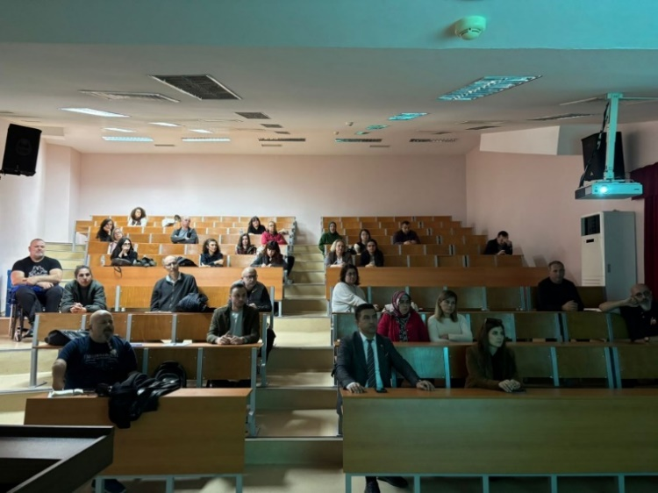

ACTIVITY: 10
Event Name: Youth Office Event
Event Date and Time: November 27, 2025, 10:00 AM
Event Location: Youth Office Center
Event Theme: Blue Bottle Cap Project
Event Purpose: As part of the blue bottle cap project, a meeting was held with Ümit BURUNLULAR, President of the TSD Çanakkale Branch and the Çanakkale Association for the Disabled, along with Hakan PENBEK and Süleyman ŞAHİN.
Speakers/Participants at the Event: Ümit BURUNLULAR (President of TSD Çanakkale Branch and Çanakkale Association for the Disabled), Hakan PENBEK, Süleyman ŞAHİN,

Brochures, posters, etc. prepared within the scope of the event (if any):
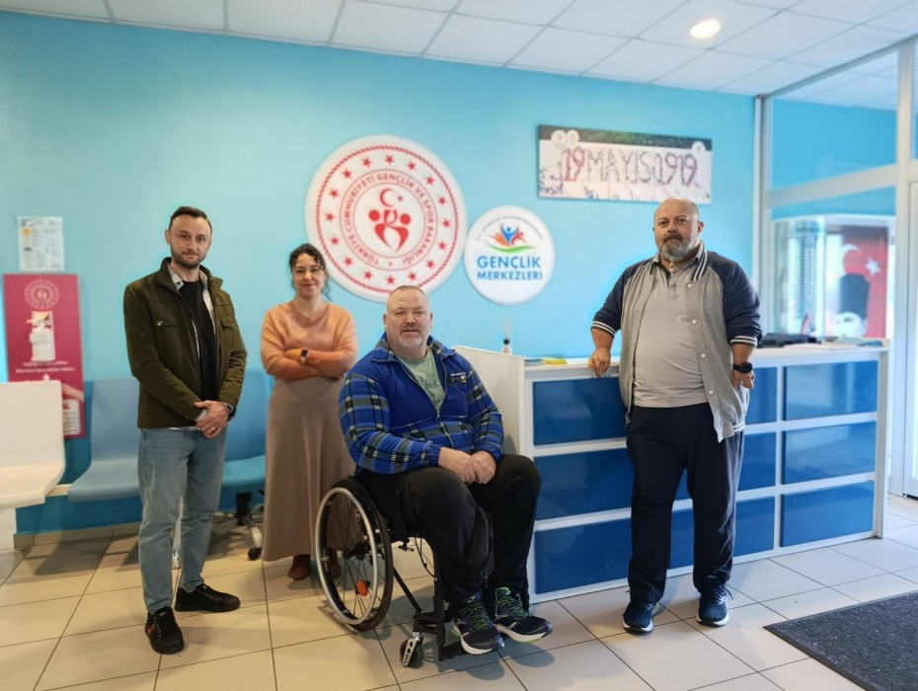
ACTIVITY: 11
Event Name: SPECIAL NEEDS IN THE NEW CENTURY / WORKSHOP
Event Date and Time: December 3, 2025, 12:00 - 17:00
Event Venue: Kolin Hotel
Event Topic: Panel and workshop on December 3rd, World Disability Day and Awareness Day.
Event Program: PANELISTS
1- Moderator - Speaker Dr. Sinan KALKAN (Faculty of Education / Department of Special Education)
"Public Services and Special Needs "
2-Prof. Dr. Mustafa Yunus ERYAMAN (Faculty of Education/Department of Primary Education)
"Exemplary Projects and Application Examples Implemented Through Public-NGO-University Collaboration for People with Disabilities"
3-Prof. Dr. Nursel TOPKAYA (Faculty of Education, Guidance/Educational Sciences Department)
"Rights-Based Advocacy in the Context of Disability"
4-Psychologist Serdar TOPAL (ÇOMÜ SKSD Presidency, Psychological Counseling and Guidance Unit)
5-"Quality of Life in the Social Integration of Individuals with Special Needs"
Dr. Ali Emrah TOKATLIOĞLU ( Erasmus Coordinator) "Inclusion and Diversity in the EU and Erasmus + Program: Policies for Equal Opportunities for All"
6-Dr. Fatma Şule BİLGİÇ (Faculty of Health Sciences/Department of Midwifery)
Management and Care of Clean Intermittent Catheter Hygiene in Male and Female Individuals with Spinal Cord Injury"
WORKSHOP PROGRAM
Ümit BURUNLULAR (President of TSD Çanakkale Branch and Çanakkale Association for the Disabled)
" Presentation and Discussion of the 2024-2025 Çanakkale Accessible Workshop Final Report"
Target Audience: Individuals with Disabilities
Speakers/Participants at the Event: Çanakkale Deputy Governor Ömer Şahin, ÇOMÜ Rector Prof. Dr. R. Cüneyt ERENOĞLU , Çanakkale Wars Gallipoli Historical Area President İsmail KAŞDEMİR, Vice Rector Prof. Dr. Evren Karayel GÖKKAYA, members of the Çanakkale protocol, NGO representatives, academics, citizens, Hakan PENBEK, Süleyman ŞAHİN.

Brochures, posters, etc. prepared within the scope of the event (if any):

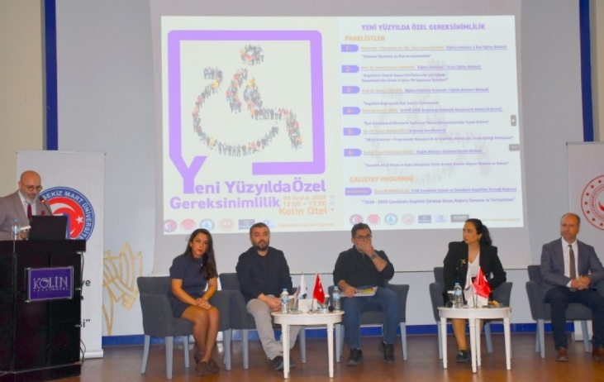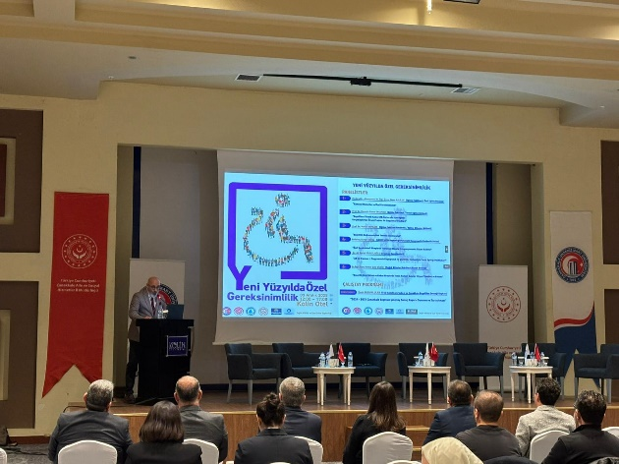

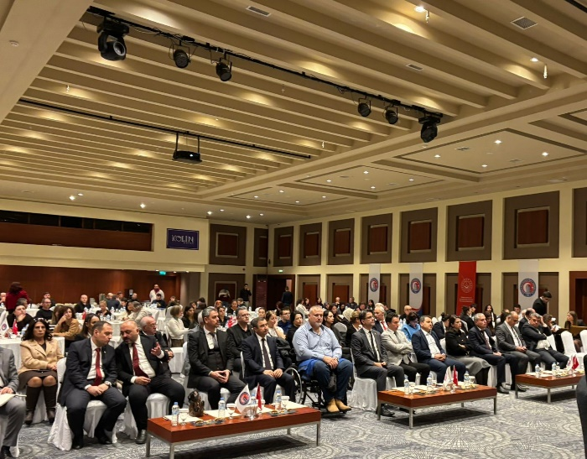

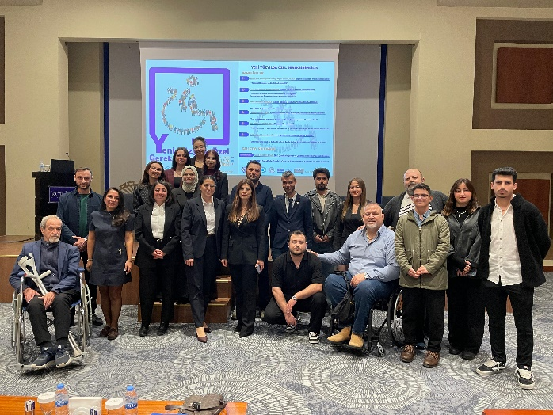

ACTIVITY: 12
Event Name: December 3rd World Disability Day Awareness Event
Event Date and Time: December 4, 2025, 10:00 AM
Event Venue: Kolin Hotel
Event Theme: 3 December World Disability Day Social Gathering Breakfast
Event Program: On the occasion of December 3rd, World Disability Day awareness day, a get-together breakfast was organized at Kolin Hotel with the sponsorship of Gelibolu Special Care Center and the contributions of the Turkish Association of Disabled People (TSD) and Çanakkale Association of Disabled People, and with the participation of ÇOMÜ Rector Prof. Dr. R. Cüneyt Erenoğlu and Vice Rector Arda Aydın.
Event Objective: Ümit Burunlular, President of the Çanakkale Branch of the Turkish Association of Disabled People (TSD), stated that although the accessibility law came into effect in 2005, progress in Çanakkale is only at around 60 percent, and that this event offers an important opportunity to evaluate shortcomings and solutions.
Target Audience: Individuals with Disabilities
Speakers/Participants at the Event: ÇOMÜ Rector Prof. Dr. R. Cüneyt Erenoğlu, Vice Rector Arda Aydın, President of the Turkish Association of Disabled People Ümit BURUNLULAR, Hakan PENBEK, Süleyman ŞAHİN,
Visual materials (photos and videos) related to the event:

