3 UNITS OF BAG-TYPE INDUCTION LOOP SYSTEM DEVICES

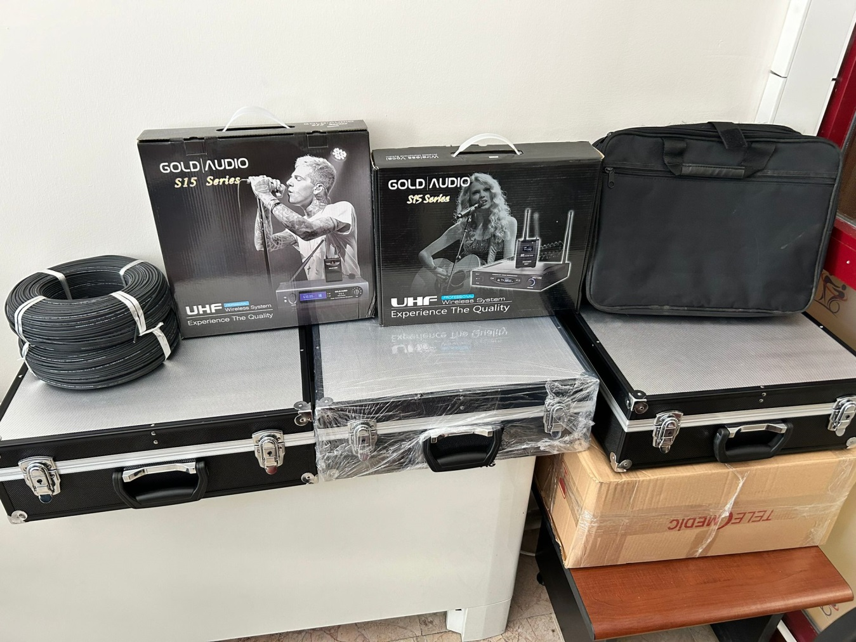

BAG MEDICINE INDUCTION LOOP INTELLIGENT HEARING SYSTEM TECHNICAL SPECIFICATIONS

Definition:

Hearing disabled device users suitable helper listening technologies to be able to access To ensure this, many countries have legislation developed and selected BAG TYPE INDUCTION How much of a loop system
Good performance can show about all in the world acceptance done And access levels It has adopted standards that define these standards.

Aim:

If the portable induction loop system is installed and used correctly, it meets the International standards for hearing aid systems. Electrical engineering Commission by determined performance standards consistent will somehow address and alleviate the difficulties that hearing-impaired individuals experience in public spaces.
It will be overcome . CRPD All World throughout disabled people person their rights protecting And supporting
international One It is an agreement. Bag medicine induction loop system equality agreement providing There must be a system .

Scope:
Discrimination without being done law in front equality inclusive One education And Good One life Standard Social participation and support for living in society through an induction cycle of accessible physical environments and information.
It is provided to the public. open to performances from participating or discussions from participating full aspect
benefit from it , a hearing-impaired person needs to receive an amplified signal in both sound level and signal-to-noise ratio. To provide this enhanced sound level, an induction loop system, widely used throughout the world, must be installed. A hearing system is suitable for meeting rooms, conference halls, mosque, hearing halls, lesson classes, receptions , ticket offices And banks, elevators, By locating them in noisy areas such as train stations, CRPDEs will be protecting and supporting the rights of people with disabilities .
The company must be the manufacturer/importer or authorized distributor of the product it is offering and must submit this documentation to the administration. Importer manufacturer or official sales person firm ISO 9001:2008 standard owner should be The product must be CE certified. It must offer a 2-year warranty and a 10-year spare parts guarantee after sale.

These features -most little the following like will be:

Bag type Induction loop device magnetic spread250 M2 area will include broadcasting will create
magnetic area power owner 1500mA/m ( rms ) +/- 3 dB will be in a way It should be done.
In the amplifier AGC ( automatic gain) Control ) should be found, AGC attack duration 2-500 ms It should be within that range .
The system frequency reaction ( frequencyresponse ) ), calibration post- tests behind 1kHz at the level
+/-3dB inside should be.
System amplifier exit current -most little 200 Arms ,exit voltage 15 Vpp -7.5 Vrms The system amplifier must have a frequency range of at least 75-6,500Hz (+/-3dB).

In the amplifier sound distortion 1%!in under should be.
Amplifier -most little 1 sound signal to its source service able to entrance owner The portable amplifier should have a headphone jack .
The loop coil signal is displayed on the output LED on the front panel. VU meter It should be a power indicator. With the system together 100 metre Induction Loop coil 2x 1.5 TTR cable with This should be done. The ATM microphone with a 2-meter cable must be included with the product.
Amplifier on TELE COIL logo should be.
Guarantee:
The portable induction loop system should be covered by a 2-year warranty. Within the warranty period... formed malfunctions 2 working day inside intervention will be done And fault intervention following -most late
15 working day inside eliminated will be. Guarantee scope inside call in case of malfunctions system The parts will be replaced free of charge.

TECHNICAL SPECIFICATIONS:

Parasite blocking 225 kHz-1 MHz high switch frequency owner should be

Max Exit Voltage: 200 Vpp should be

Max Exit The current, 7.5 Arms should be

Peak Exit Current ( speech ): 2x20 App should be

Loop Flow Settings: head shrill volume potentiometer​ 8LED indicator ) Monitor Output must be: canon It should be a jack.
Alarm entrance conon It should be a jack.

Microphone 2 piece entrance nail jack should be

Strength Indicator: BLUE LED indicator Cooling must be: Fanless cooling must be present.
Bag Size: 430mm x 130mm x 44 mm, Aluminum from the material coups resistant The weight should be 6 kg.
Magnetic area power 400 mA /m ( rms ) +/- 3 Db should be

