BRAILLE ALPHABET PRINTER
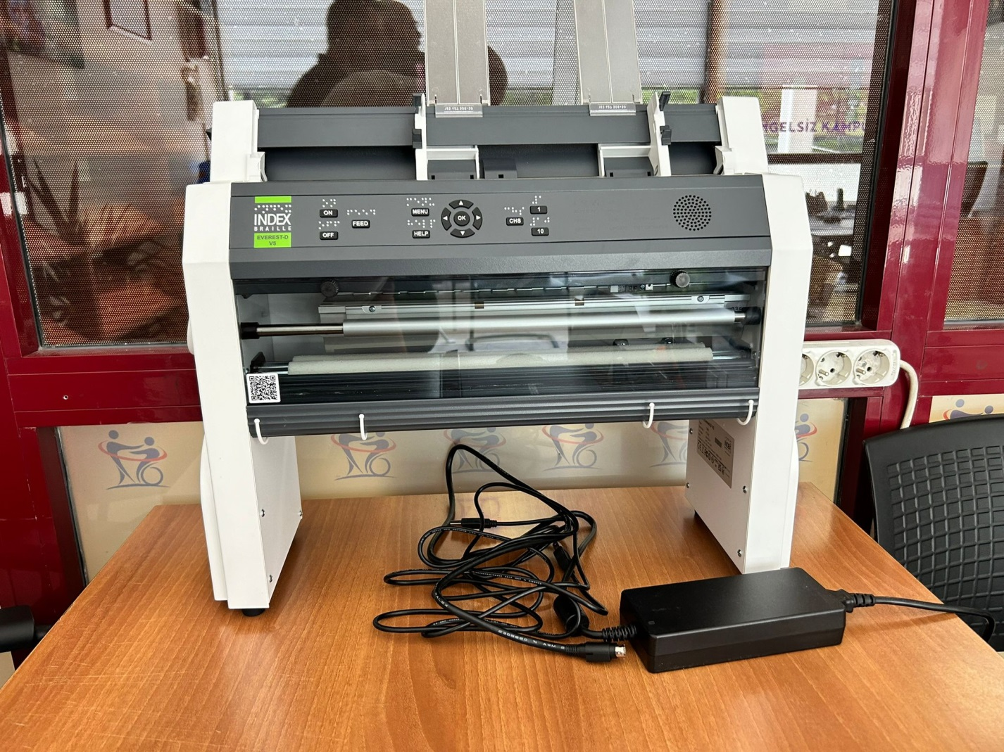

TECHNICAL SPECIFICATIONS
1. Embossing Printer (1 Unit)
- Turkish texts should be able to be printed in Braille by sending them directly to the printer.
- The machine must use sheet format paper (cut into pages) and be able to print in fascicle format.
- It should be able to print 140 characters per second.
- It should have a paper feeder with a capacity of 50 sheets.
- It must have USB and parallel ports.
- The device must be compatible with mobile smart devices.
- The machine's buttons should have embossed labels.
- All menu options and messages on the machine should be in Turkish voiceover.
- The dot formation height should be 0.58 mm.

2. Braille Writing Paper (1 Pack)
- It should be 160 grams of raw dough.
- Each pack should contain 1000 sheets in A4 format.
- It must be white.

3. BRAILLE TRANSLATION PROGRAM (1 UNIT)
- It should be able to translate printed texts into Braille in more than 180 different languages, including Turkish.
- It should be able to import many file types, including files in many different languages and with many different scripts.
- It should be able to translate from Braille to print in approximately 170 different languages.
- It should provide support for the specialized processing of foreign languages in Braille.
- The user interface language should include 15 different options.
- It should allow you to read the DBT Help files in over 135 different languages using Google Translate (internet connection required).
- It should allow Braille characters to be entered and displayed in a way that matches the different international character map settings in screen readers.
- It should support various specialized braille page formatting systems.
- It should be available on Windows and Mac.
- It must be for 1 user.

