LECTURE ANNOUNCEMENT
As part of the ERASMUS Program, Prof. Dr. Agnieszka Nosal-Wiercińska from the Department of Analytical Chemistry, Institute of Chemical Sciences, Faculty of Chemistry, Maria Curie-Skłodowska University in Lublin, Poland, and Prof. Dr. Robert Pietrzak from the Faculty of Chemistry, Adam Mickiewicz University in Poznan, as well as their PhD student Alicja Pawlak, will visit our Faculty of Science Dean's Office and Department of Chemistry from November 10-14, 2025. PhD student Alicja Pawlak will present the lecture titled “At the Interface: Electrochemical research and scientific collaboration” on Tuesday, November 11, 2025, at 1:30 pm in the Faculty of Science, Classroom 144.

Prof. Dr hab. Agnieszka Nosal - Wiercińska graduated in chemistry in 1999 from the Faculty of Chemistry at UMCS in Lublin and has linked his professional career with this university. In 2006, she obtained a PhD in chemistry, in 2015 a postdoctoral degree in chemistry, and in 2021 the academic title of professor. Together with her research group, she works at the Department of Analytical Chemistry of the Institute of Chemical Sciences and of the Faculty of Chemistry at Maria Curie - Skłodowska University in Lublin. The research interests of Prof. Agnieszka Nosal-Wiercińska include studies of electrode mechanisms of selected depolarisers, the cap-pair effect, and adsorption phenomena occurring at phase boundaries: electrode–solution, solid–solution, and carbon adsorbents. She is the author or co-author more than 200 scientific papers, including 120 published in the journals from the ISI Master Journal List. She has been included in the prestigious ranking of the world's most influential people in science - the World's Top 2% Scientists (a list of the 2% most cited scientists in the world according to the Stanford Ranking). She is a co-author of three patents and one patent application. Three doctoral theses have been completed under the supervision of Prof. Agnieszka Nosal-Wiercińska, and one is currently in progress. She has supervised 45 master's theses and 78 bachelor's theses. Prof. Agnieszka Nosal-Wiercińska is a co-founder and chair of the Scientific Board of the Golden Age University in Biecz; vice-chair of the Electroanalysis Team of the Analytical Chemistry Committee of the Polish Academy of Sciences; chair of the Committee for the Development and Promotion of the Achievements of Young Scientists of the Polish Academy of Sciences, Lublin Branch.; International Society of Electrochemistry (ISE), editorial board of the Journal of Scientific Perspectives and the Turkish Journal of Analytical Chemistry. Since 2019, Professor Agnieszka Nosal-Wiercińska has been the faculty coordinator of the Croatian Network ‘Colloids and nanomaterials in education and research’ CIII-HR-1108-03-1920, CEEPUS). Since 2022, she has been the Treasurer of the Polish Chemical Society.

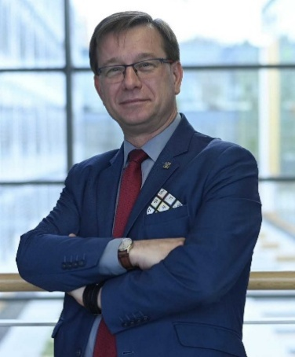
Prof. Robert Pietrzak graduated in chemistry in 1998 from the Faculty of Chemistry at Adam Mickiewicz University in Poznań and has linked his professional career with this university. In 2002, he obtained a PhD in chemistry, in 2010 a postdoctoral degree in chemistry, and in 2017 the academic title of professor. Together with his research group, he works at the Department of Applied Chemistry of the Faculty of Chemistry at Adam Mickiewicz University. His scientific interests include chemical technology, chemistry and technology of coal and carbon materials, adsorption, and environmental protection - topics that are among the most current global research trends today. He is the author or co-author more than 360 scientific papers, including 181 published in the journals from the ISI Master Journal List. According to Scopus database the number of citations is almost 6000 and the Hirsch index 45. Every year since 2020, he has been included in the prestigious ranking of the world's most influential people in science - the World's Top 2% Scientists (a list of the 2% most cited scientists in the world according to the Stanford Ranking). Prof. Pietrzak promoted 5 PhD students, 46 MSc students and 77 licentiate students. Currently, for the 2024-2028 term, he serves as Vice-Dean for Organisational Affairs of Chemistry AMU Poznań and President of Polish Chemical Society for the 2025-2028 term.
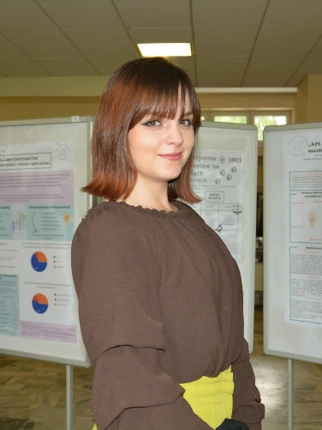
Alicja Pawlak, Msc. is a PhD student in Chemical Sciences at The Doctoral School of Quantitative and Natural Sciences, Maria Curie-Skłodowska University in Lublin. My research focuses on the electrochemistry of post-transition metal ions, particularly Bi(III) and In(III), with special emphasis on the influence of reaction media and surfactants on the kinetics and mechanisms of electrode processes. She is the co-author of papers published in JCR-listed journals and an active participant in national and international scientific conferences.In previous years, She was several times awarded the Rector’s Award for the Best Students of Maria Curie-Skłodowska University. For several years, She has been actively involved in the local scientific community as an organizer of conferences and science festivals, promoting chemistry and supporting the development of young researchers. Since 2025, She has been serving as Chair of the Young Chemists’ Section of the Polish Chemical Society and as the Polish Delegate to the European Young Chemists’ Network (EYCN). She is strongly committed to science communication and to initiatives promoting collaboration and integration within the community of young chemists in Poland and abroad.
Research interests:
• electrochemistry of post-transition metal ions
• kinetics and mechanisms of electrode processes
• “cap-pair” effect in aqueous–organic systems
• electrode and nanostructured materials in the context of sustainable development

