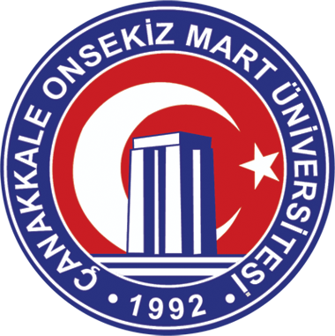 | CANAKKALE ONSEKIZ MART UNIVERSITY  OUTGOING STUDENT  APPLICATION FORM | Photo

STUDENT’S PERSONAL DATA
Name
Surname
Tel
Fax
E-mail
Address

Date of birth
Gender
Nationality
Person to contact in case of emergency | Name :  Tel:  E-mail :

PREVIOUS AND CURRENT STUDY
Faculty, Department
Diploma/degree for which you are currently studying | ( ) Pre-degree  ( ) Bachelor’s / Degree / Undergraduate  ( ) Master’s  ( ) Doctorate
Which year are you studying at the moment? | ( ) 1st ( x ) 2nd ( ) 3rd  ( ) 4th ( ) 5th ( ) 6th
Which academic year and term do you want to participate in exchange program? | 20… /20….  ( ) Autumn ( ) Spring

LANGUAGE COMPETENCE
Mother tongue: ………………

 | A1 | A2 | B1 | B2 | C1 | C2
English
..……..

WORK EXPERIENCE
Type of work experience | Firm/organisation | Dates | Responsibilities

SENDING INSTITUTION
Name in Original Language | ÇANAKKALE ONSEKİZ MART ÜNİVERSİTESİ
Name in English | Canakkale Onsekiz Mart University
Contact Person  Name, address, tel, fax, e-mail | Mr. Hasan Hakan BASARAN  Canakkale Onsekiz Mart University  International Relations Office  Building of Faculty of Political Sciences, Ground Floor  Terzioglu Campus  17020 Canakkale, Turkey  Tel : + 90.286.218 00 18 / Ext. 12009  Fax : + 90.286.218 19 49  http://isbirligi.comu.edu.tr
WHY DO YOU WANT TO PARTICIPATE IN STUDENT EXCHANGE ?

STUDENT DECLARATION
I hereby confirm that all the information given above is accurate and correct.

Signature:

Date :

