**The First International Conference on Mathematics and Applied Data Science (ICMADS‘25)**

We are pleased to announce that **The First International Conference on Mathematics and Applied Data Science (ICMADS’25)** will be held between **August 29-31, 2025** at [**Necmettin Erbakan University, Konya, Türkiye**](https://icmads.org/location/) in a **hybrid format** where both physical and remote participation will be allowed. The aim of this conference is to bring together leading researchers, leading experts and academics in the field of Mathematics and Data Science in order to explore and exchange ideas at the intersection of mathematics and data science, fostering innovation and collaboration.

**Conference Topics**

The conference will focus on (but is not limited to) the following areas:

* **Mathematics**:
  + Computational Mathematics
  + Control Theory and Applications
  + Mathematical Biology and Ecology
  + Fractional Calculus with Applications
  + Nonlinear Dynamical Systems & Chaos Theory
  + Analysis
  + Algebra
  + Geometry
  + Topology
* **Data Science Applications in Mathematics**:
  + Computational and Mathematical Neuroscience & Medicine
  + AI & Machine Learning Applications
  + Optimization & Operations Research
  + Mathematical Finance, Marketing & Risk Analysis
  + Data Science in Engineering
  + Data Science in Energy Management
  + Computational Statistics and Probability
  + Data Science in Education and Natural Sciences

**Submission Guidelines**

**ICMADS’25** welcomes all original submissions electronically via [**Microsoft CMT system**](https://cmt3.research.microsoft.com/ICMADS2025). All authors need to submit their abstracts in **English** (min 250 words, no more than one page including references) within the deadline making sure that all author details are complete.

The papers must be submitted by the corresponding author (who is expected to be the presenting author and identified clearly when doing so). All abstracts must be prepared according to the template available at **[this link (click here)](https://icmads.org/wp-content/uploads/2025/02/ICMADS_AbstractTemplate.docx" \t "_blank)** and presentations must be done in English.

Abstracts will be evaluated by the scientific committee of the conference, and at least two scientific referees will be assigned for each paper. Accepted abstracts will appear in a short book of abstracts with an ISBN.

Note that the full-text papers will be submitted “after” the conference. Please **[click here](https://icmads.org/proceedings/" \t "_blank)** to see the full-text opportunities.

For further details, you can view the [**Conference Flyer.**](https://icmads.org/wp-content/uploads/2025/03/afis.png)

**Proceedings**

The abstracts of the papers presented at the conference will be published in the “*Abstracts Book*” and will be considered for full-text publication after the conference. For inclusion in the final program and in the conference abstracts book, **at least one must have been registered** by the late registration deadline.

**1- ABSTRACTS BOOK**  
  
All abstracts registered and presented at the conference are published in the Book of Abstracts to be published by [**Necmettin Erbakan University Publishing House (NEU PRESS)**](https://neupress.org/en).

**2- FULL-TEXT PUBLICATION**

The authors who have presented their research at the conference will have the opportunity of publishing their extended full-text papers based on the selection by the committee. Note that the full-text papers will be submitted “after” the conference. The committee will contact the authors to provide instructions.

**a) Proceedings Book**  
All authors are welcome to prepare the full text of their paper (8-10 pages) and submit it to the conference proceedings to be published by [**NEU PRESS**](https://neupress.org/en).

**b) Edited Books:** The selected papers will be published as part of a book series by **World Scientific Publishing House** (**[In Book Series: Systems Science & Nonlinear Intelligence Dynamics](https://www.worldscientific.com/series/ssnid?srsltid=AfmBOoo_EZExlRRNJ70iDRo-G2-dX712_Z-tp363QUj6ihCafZMhaMu_" \t "_blank)**). Further details will be provided upon the finalization of the agreements. Publishing in the books does not charge any fees to the authors.  
  
**c) Journal Publications:** The committee is actively negotiating agreements with esteemed academic journals to publish a curated selection of high-quality papers centered on a specific theme. The selection criteria for inclusion in a special issue will be strictly aligned with the aims and scope of the respective journal. As each journal has its own submission procedures, authors are required to adhere to the specific guidelines of their chosen publication. All submissions will undergo a rigorous peer-review process, with the final decision on publication resting with the journal editors. The list of the journals confirmed are as follows:



[**Discrete and Continuous Dynamical Systems – Series S (DCDS-S)**](https://www.aimsciences.org/dcds-s)

*(SCIE-Q2 and SCOPUS)*

***SpeciaI Issue Title:****Recent Advances in Mathematics and Applied Data Science*  
Details of the SI will be provided soon.

This Special Issue is the second volume of the previously published SI in the journal.[**Please click to see the first volume of the Special Issue**](https://www.aimsciences.org/DCDS-S/article/2025/18/5)

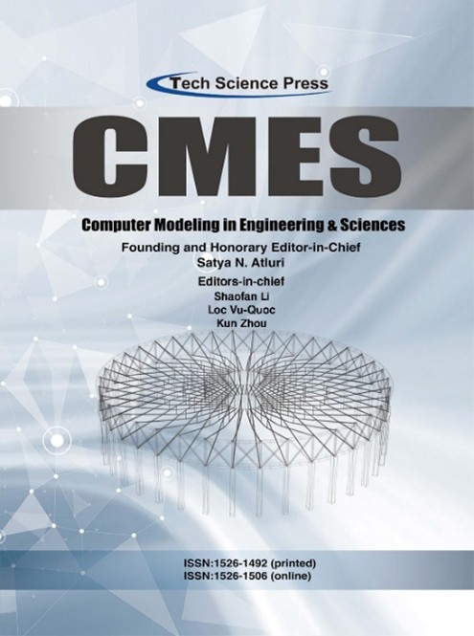

[**Computer Modeling in Engineering & Sciences**](https://www.techscience.com/CMES/special_detail/fractional_modeling)

*(SCIE-Q2 and SCOPUS)*

***SpeciaI Issue Title:****Innovative Applications of Fractional Modeling and AI for Real-World Problems*[**Please click to see the proposal.**](https://www.techscience.com/CMES/special_detail/fractional_modeling)



[**Mathematical Modelling and Numerical Simulation with Applications**](https://dergipark.org.tr/tr/pub/mmnsa)

*SCOPUS (Q1 – CiteScore: 13.0) and ULAKBIM (TR Dizin)*

*The authors of the selected high-quality papers presented at ICMADS’25 will be invited to submit considerably extended versions to the Special Issue. The papers must suit the aim and scope of the journal and prepared according to the journal’s guidelines.*

*Special Issue proposal and submission guidelines will be provided soon on the journal webpage*.

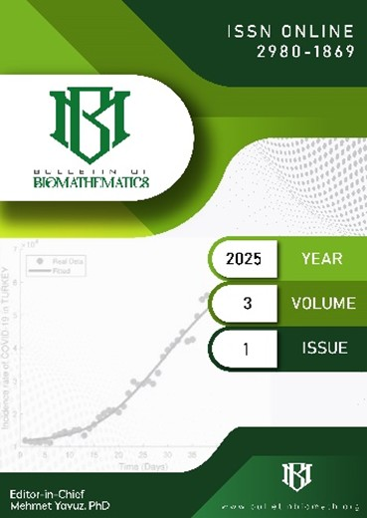

[**Bulletin of Biomathematics**](https://bulletinbiomath.org/index.php/bulletinbiomath)

*ULAKBIM (TR Dizin)*

*The authors of the high-quality papers presented at ICMADS’25 are invited to submit considerably extended versions to the journal. The papers must suit the aim and scope of the journal and prepared according to the journal’s guidelines.*

*Special Issue proposal and submission guidelines will be provided soon on the journal webpage*.

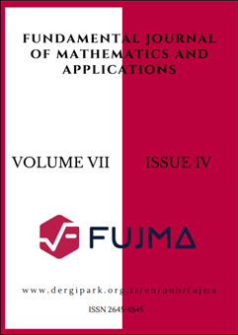

[**Fundamental Journal of Mathematics and Applications**](https://dergipark.org.tr/en/pub/fujma)

*ULAKBIM (TR Dizin) and DOAJ*

*The authors of the high-quality papers presented at ICMADS’25 are invited to submit considerably extended versions to the journal. The papers must suit the aim and scope of the journal and prepared according to the journal’s guidelines.*

*Special Issue proposal and submission guidelines will be provided soon on the journal webpage*.



[**Control and Optimization in Applied Mathematics**](https://mathco.journals.pnu.ac.ir/)

*SCOPUS and DOAJ*

*The authors of the high-quality papers presented at ICMADS’25 are invited to submit considerably extended versions to the journal. The papers must suit the aim and scope of the journal and prepared according to the journal’s guidelines.*

*Special Issue proposal and submission guidelines will be provided soon on the journal webpage*.



[**Research in Mathematics**](https://www.tandfonline.com/journals/oama23)(Taylor and Francis Group)

*Emerging Sources Citation Index (ESCI) and SCOPUS*

*The authors of the high-quality papers presented at ICMADS’25 are invited to submit considerably extended versions to the journal. The papers must suit the aim and scope of the journal and prepared according to the journal’s guidelines.*

*Special Issue proposal and submission guidelines will be provided soon on the journal webpage*.



[**Discover Data**](https://link.springer.com/journal/44248)(Springer Nature)

*DOAJ*

*The authors of the high-quality papers presented at ICMADS’25 are invited to submit considerably extended versions to the journal. The papers must suit the aim and scope of the journal and prepared according to the journal’s guidelines.*

*Special Issue proposal and submission guidelines will be provided soon on the journal webpage*.

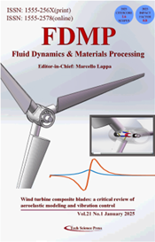

[**Fluid Dynamics & Materials Processing**](https://www.techscience.com/journal/fdmp)

*Emerging Sources Citation Index (ESCI) and SCOPUS*

*The authors of the high-quality papers presented at ICMADS’25 are invited to submit considerably extended versions to the journal. The papers must suit the aim and scope of the journal and prepared according to the journal’s guidelines.*

*Special Issue proposal and submission guidelines will be provided soon on the journal webpage*.



[**Advances in Differential Equations and Control Processes**](https://ojs.acad-pub.com/index.php/ADECP/)

*Emerging Sources Citation Index (ESCI)*

*The authors of the high-quality papers presented at ICMADS’25 are invited to submit considerably extended versions to the journal. The papers must suit the aim and scope of the journal and prepared according to the journal’s guidelines.*

*Special Issue proposal and submission guidelines will be provided soon on the journal webpage*.



[**International Journal of Data Science in the Mathematical Sciences**](https://www.worldscientific.com/worldscinet/ijdsms)

*EBSCO and Mathematical Reviews / MathSciNet*

*The authors of the high-quality papers presented at ICMADS’25 are invited to submit considerably extended versions to the journal. The papers must suit the aim and scope of the journal and prepared according to the journal’s guidelines.*

*Special Issue proposal and submission guidelines will be provided soon on the journal webpage*.