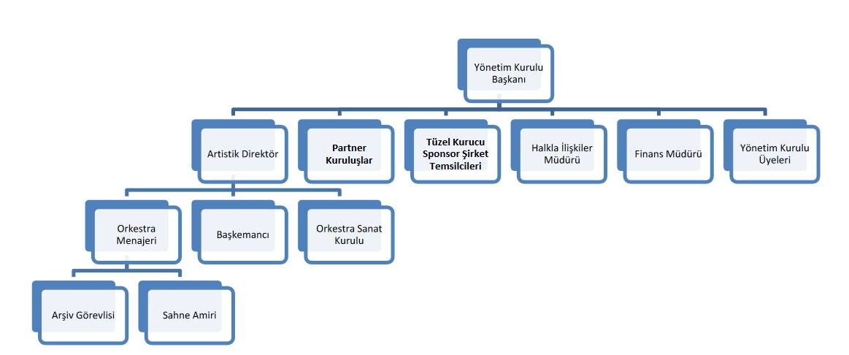

**Organizational Chart (251-teskilat-semasi.docx)**

**Management Structure**

* **Chairman of the Board (YKB):** Uğur TÜRKMEN
* **Artistic Director (AD):** Cihat AŞKIN
* **Orchestra Manager:** Bahadır ÇOKAMAY
* **Archivist:** Barış KARABULUT
* **Concertmaster (Principal Violinist):** Eda DELİKÇİ

**Partners:**

* Çanakkale Municipality
* Çanakkale Onsekiz Mart University
* Music Practice and Research Center
* Association for the Development of Music and Performing Arts

**Public Relations Officer:** Ulaş ÇABUK