EXPERIMENTAL OF SEDIMENTATION
Wastewater treatment consists of applying known technology to improve or upgrade the quality of a wastewater. Wastewater treatment involves collecting the wastewater in acentral, segregated location and subjecting the wastewater to various treatment processes. The principal objective of wastewater treatment is generally to allow human and industrial effluents to be disposed off without danger to human health or unacceptable damage to the natural environment. With the current emphasis on environmental health and water pollution issues, there is an increasing awareness of the need to dispose of these wastewaters safely and beneficially. Conventional wastewater treatment consists of a combination of physical, chemical and biological processes and operations to remove solids, organic matter and sometimes, nutrients from wastewater. General terms used to describe different degrees of treatment, in order of increasing treatment level, are preliminary, primary, secondary, and tertiary and/or advanced wastewater treatment. The objective of preliminary treatment is the removal of coarse solids and other large materials often found in raw wastewater. The purpose of secondary treatment is the further treatment of the effluent from primary treatment to remove the residual organics and suspended solids and tertiary and/or advanced wastewater treatment is employed when specific wastewater constituents which cannot be removed by secondary treatment must be removed. Gravity separation of solids from liquid, producing a clarified overflow and a thickened solids underflow, has long been used in the wastewater treatment industry. Often, the terms clarification and thickening or sedimentation are used to describe gravity separation unit operations, depending on if the process focus, or objective, is on the clarified liquid or the thickened solids, respectively. In the practice of water management, studying the phenomenon of solid particles sedimentation in water provides very important experimental data, both for the proper design and exploitation of decanted impurities separation equipment or sludge thickeners from wastewater treatment plants and for the efficient administration of natural water courses.
Sedimentation is the oldest and most widely used operation in the effective treatment of wastewater. The operation consists of removing sediment, turbidity and floating material from raw wastewater, operation performed by settler tanks. The process of sedimentation of solids in water is used in both the primary stage and the secondary stage to the waste.
water is made to flow very slowly in order to promote the sedimentation of particles or flocs. In water and wastewater treatment plants, these are so large that they are situated outdoor and usually have an open surface. Sedimentation basins come in two shapes, rectangular and circular. Longitudinal horizontal decanters concrete basins are characterized by their rectangular shape plan and horizontal direction of water flow. The lengths of these separators are an average of up to 30 m and 100 m; the average depth is 3 m and 4 m maximum. With round sedimentation tanks the wastewater is fed into the middle and is discharged through a trough on the outer periphery. A final step, known as secondary clarification, allows wastewater to settle before it is reintroduced into the environment or sent for further treatment, which is often referred to as tertiary treatment. The study of solid particles sedimentation in water is done both for stationary systems (stationary columns) and for dynamical systems (currents with different flow directions). For stationary columns, if in a glass tube there is introduced a certain amount of diluted suspension composed of water and solid particles and let it rest, it can be observed after a period of time the appearance of distinct areas, (figure 1) such as: clear liquid zone at the top of the tube, a zone with water in which solids are in the sedimentation process at the middle of the tube and a zone with concentrated sludge settled at the bottom of the column.
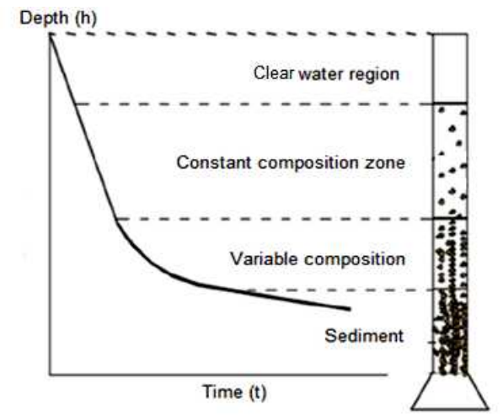
Figure 1. Suspension settling in the column
MATERIAL AND METHOD
The study of solid particles sedimentation in water is done both for stationary systems (stationary columns) and for dynamical systems (currents with different flow directions). Experimental study of sedimentation process in stationary column of different aqueous suspension of solid particles has as main result the possibility of obtaining clarifying curves which, besides giving a complete image about how the water is clarified during the process, allow through the various processing to obtain important characteristics parameters. Experimental studies of sedimentation process in stationary column were performed on a laboratory stand, manufactured by Armfield Limited, England, UK, which is equipped with five glass columns with an inside diameter of .. mm and the useful height (with scale) of … mm (Figure 2)
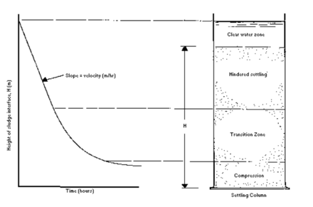
Figure 2. Difference between heights according to time during sedimentation
Suspensions used were composed of water and powdered calcium carbonate with concentrations of 2%, 4%, 6%, 8% and 10%. These concentrations correspond to an amount of 15g, 30g, 60g, 90g, 120g and 150g. Powdered calcium carbonate was added in the five columns properly, then water was added up. Suspension volume in each column was 1.5 l. It was registered the clarified water – suspension interface position at regular intervals 0.05 h (3 minutes) for one hour.
It should be noted that a slow stirring foster the sediment compaction process that forms on the settlers’ foundation. Based on registered values, were plotted variation curves as a function of time for clarified water – suspension interface.
RESULTS AND DISCUSSIONS
The results obtained in the process of settling in stationary column are shown in Table 1. If the observation is continued, it is observed that the clarified water – concentrated sludge settled interface descends very slowly (the speeds are much lower than the descend speed of clarified water – suspension interface from the first part of this process).

Interface height of clarified water - suspensions at different concentrations [%] /  Time [min] | 1 % | 2 % | 4 % | 6 % | 8 % | 10 %
0
3
6
9
12
15
18
21
24
″
″
″
60

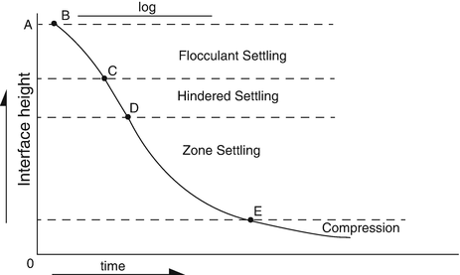
Figure 3. Types of sedimentation
If the experiment is continued, it is observed that the clarified water - concentrated settled sludge interface descends very slowly over time (the speeds are much lower than the descend speed of clarified water-suspension interface from the first part of this process) properly to the settled sludge compaction process, and after a long period of time the interface position of clarified water - concentrated settled sludge is stabilized at a certain height that does not undergo changes. Based on registered values, were plotted variation curves as a function of time for clarified water – suspension interface. Following these graphics, you can see that: - suspension at a concentration of 2% starting position clarified water interface - suspension is ….. cm and get in one hour to …. cm
- suspension at a concentration of 4% starting position clarified water interface - suspension is ….. cm and get in one hour to …. cm

