**1. Stock Standard Solution**

* Stock solution is prepared in high concentration by dissolving the desired chemical in a solvent.
* The prepared stock solution can be stored for a long time under specific storage conditions.
* All stock standards shall be checked before use with another standard that has been prepared separately from different source.
* To prepare stock standard solution you should make sure that you understand the concentration units and some mathematical rules which will help to find exact answer for reporting.

**2. Expressing Concentration of Solute**

* Concentration is a general measurement unit stating the amount of solute present in a known amount of solution:

Concentration = $\frac{Amount of Solute}{Amount of Solution}$

**Table 1.1:** Common Practical Units for Reporting Concentration

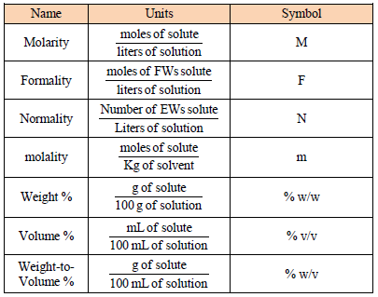

**2.1. Molarity and Formality**

* Molarityis the concentration of a particular chemical species in solution.
* Formalityis a substance’s total concentration in solution without regard to its specific chemical form.

Molarity (M) = $\frac{Moles of Solute}{Volume of Solution (L)}$

Moles of solute= $\frac{Weight of Solute (g)}{Molecular Weight (\frac{g}{mol})}$

* A solution of known molarity is prepared by weighing an appropriate amount of chemical and placing it in a volumetric flask.

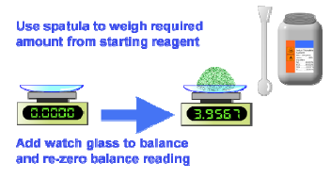

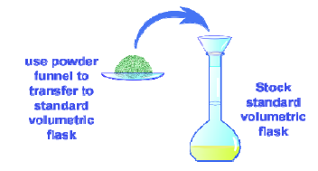

* Enough solvent is added to dissolve the solute by swirling.

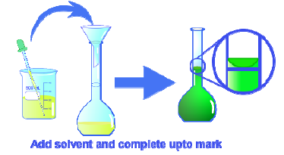

* Further solvent is carefully added until the calibration mark on the neck of the flask is reached, and the solution is then shaken until uniform.

**Example 2.1.**

What is the molarity of a solution made by dissolving 2.355 g of sulfuric acid in water and diluting to a final volume of 50.0 mL?

**SOLUTION**

Molarity is the number of moles of solute per liter of solution. Thus it’s necessary to find the number of moles of sulfuric acid in 2.355 g and then divide by the volume of the solution.

Molar mass of H2SO4 = ( 2 x 1.0 g/mol) + (1 x 32.1 g/mol) + (4 x 16.0 g/mol) = 98.1 g/mol

2.355 g ~~H~~~~2~~~~SO~~~~4~~ x=0.0240 mol H2SO4

Molarity = $\frac{Moles of Solute}{Volume of Solution (L)}$ = $\frac{0.0240 mol H2SO4}{0.0500 L}$ = 0.480 M

The solution has a sulfuric acid concentration of 0.480 M.

**Example 2.2.**

Hydrochloric acid is sold commercially as a 12.0 M solution. How many moles of HCl are in 300.0 mL of 12.0 M solution?

**SOLUTION**

The number of moles of solute is calculated by multiplying the molarity of the solution by its volume.

Moles of HCl = (Molarity of solution) × (Volume of solution L)

= $\frac{12.0 M HCl}{1 L Solution}$ x 0.300 ~~L~~ =3.60 mol HCl

There are 3.60 mol of HCl in 300.0 mL of 12.0 M solution.

**2.2. Normality**

* 1 L of the solution is the equivalent number of grams of the solute.
* Normality is the number of equivalent weights (EW) per unit volume and, like formality, is independent of speciation. An equivalent weight is defined as the ratio of a chemical species’ formula weight (FW) to the number of its equivalents.
* The number of H+ ions that acids give to the environment, the number of OH-ions that bases give to the environment, the number of electrons that salts give or take to the environment is called the effect valence (n).

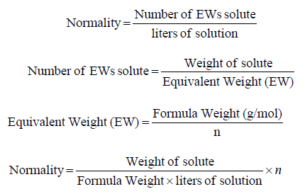

* Consequently, the relation between normality and molarity is stated below:

Normality (N) = n * M

**Example 2.3.**

Calculate the equivalent weight and normality for a solution of 6.0 M H3PO4 given the following

reactions:

(a) H3PO4(*aq*) + 3OH-(*aq*) →PO43-(*aq*) + 3H2O(l)

(b) H3PO4(*aq*) + 2NH3(*aq*) →HPO42-(*aq*) + 2NH4 +(*aq*)

(c) H3PO4(*aq*) + F-(*aq*) →H2PO4–(*aq*) + HF(*aq*)

**SOLUTION**

For phosphoric acid, the number of equivalents is the number of H+ ion donated to the base. For the

reactions in (a), (b), and (c) the number of equivalents are 3, 2, and 1, respectively. Thus, the calculated equivalent weights and normalities are

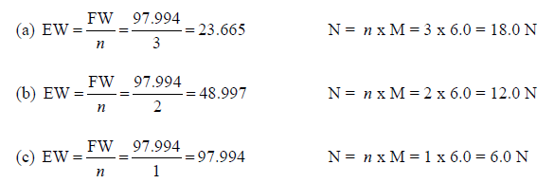

**Example 2.3.**

In standard method for Alkalinity measurement, a solution of 0.05N of Na2CO3 should be prepared

based on the following titration reaction with sulfuric acid:

Na2CO3 (aq) + H2SO4 [H2CO3] + Na2SO4 (aq) → H2O (aq) + CO2 (gas) + Na2SO4 (aq)

The part [H2CO3] is an intermediate which is directly converted to H2O and CO2 gas.

How many grams of Na2CO3 required to prepare 1.0 Liter of 0.05N solution?

**SOLUTION 1 By Normality Equations**

According to the reaction above (acid-base reaction), each molecule of Na2CO3 accept two hydrogen

ions (H+) from sulfuric acid, then number of equivalents for Na2CO3 n=2.

Formula Weight (FW) for Na2CO3 = 105.99 g/mol

Equivalents Weight (EW)= FW/n = 105.99/2 = 52.995 g/mol

Normality= Number of EWs solute/liters of solution → Number of EWs solute= Normality*Liter of solution

Number of EWs solute = 0.05 N x 1.0 L = 0.05 mol

Number of EWs solute= Weight of Solute/EW→

Weight of solute=Number of EWs Solute*EW =0.05 mol*52.995 g/mol = 2.65 g

To prepare 0.05N of Na2CO3 weigh 2.65 g of Na2CO3 and dissolve and complete to volume 1.0 L.

**SOLUTION 2 By Molarity Equations:**

Convert the normality concentration to molarity the make all calculations by molarity equations

N = *n* x M → M=N/n=0.05/2=0.025 M of NaCO3

Moles of solute = Molarity × Volume of solution (L)

Moles of solute = 0.025 M X 1.0 L = 0.025 mol of Na2CO3

Moles of Solute= Weight of solute(g)/Molecular weight(g/mol)

Weight of solute (g) = Moles of solute X Molecular Weight (g/mol)

Weight of solute (g) = 0.025 mol X 105.99 (g/mol) = 2.65 g of Na2CO3

**2.3. Molality**

* Molality is the molar number of material dissolved in one kilogram of solvent.

Molality (m) = $\frac{Moles of Solute}{kg of Solvent}$

**Example 2.4.**

What is the molalityof solution made by dissolve 25 g of NaCl in to 2.0 Liter of water. Assume the

density of water d = 1.0 g/mL (= kg/L).

**SOLUTION**

Molar mass of NaCl = (1 x 22.99 g/mol ) + (1 x 35.45 g/mol ) = 58.44 g

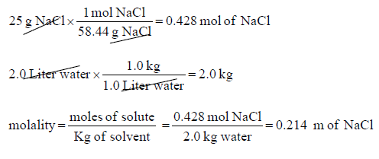

The solution has concentration of NaCl equals to 0.214 m.

**2.4. Weight, Volume, and Weight-to-Volume Ratios**

* Weight percent (% w/w), volume percent (% v/v) and weight-to-volume percent (% w/v) express concentration as units of solute per 100 units of solution.

Table 1.2: most common equations used in calculations of weight and volume ratios units.

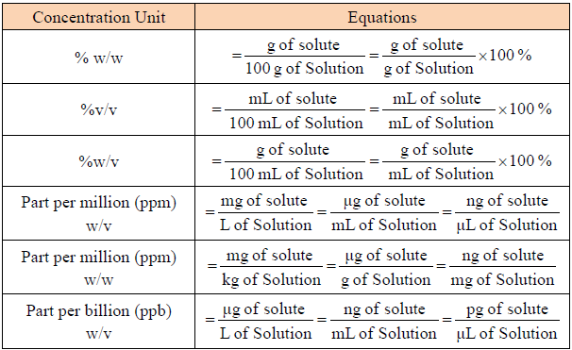

w/w: Weight by weight

w/v: Weight by volume

v/v: Volume by volume

**Example 2.5.**

How many grams of NaCl required to prepare each of the following solutions:

a) 2500 ppm (w/v) NaCl 250 mL solution.

b) 10% (w/v) NaCl in 250 mL solution.

c) 20% (w/w) NaCl in 250 g solution.

**SOLUTION**

a) 2500 ppm (w/v) NaCl

Conc. (ppm)=mg of solute/volume of solution(L)

mg of solute=Conc. (ppm)xVolume of solution(L)

mg of NaCl=2500 ppm x 0.250L = 625 mg = 0.625 g of NaCl

b) 10% (w/v) NaCl

Conc. % (w/v) = g of solute/mL of solution*100% → g of solution= $\frac{Conc.\%(w\backslash v)*mL of solution}{100\%}$

g of NaCl= $\frac{10\%\left(w\backslash v\right)*250mL solution}{100\%}$ =25 g

c) 20% (w/w) NaCl

Conc.%(w/w)= $\frac{g of solute}{g of soution}$ =100% → g of solute= $\frac{Conc.\%\left(w\backslash w\right)*g of solution}{100\%}$

g of solute (NaCl)= $\frac{20\%\left(w\backslash w\right)*250 g of solution}{100}$ = 50 g

**Example 2.6.**

What is the concentration of MgSO4 the following prepared solution, express concentrations in ppm,

%(w/v) and (w/w) concentrations units. Assume solution density is 1.0 g/mL

30 g of MgSO4 dissolved in 500 mL distilled water.

**SOLUTION**



**3. Converting Between Concentrations Units**

* The simplest way to carry out calculations that involve different units is to use the dimensional-analysis method.

Original quantity × Conversion factor = Equivalent quantity

Table 1.3: Some Prefixes for Multiples of SI Units

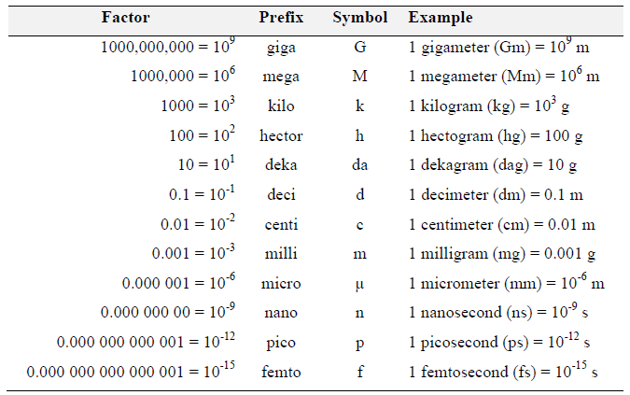

Table 1.4: Conversion between most commonly used volume units.

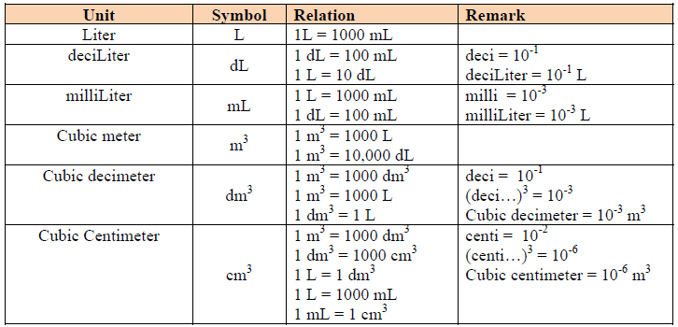

**Example 3.1.**

A concentrated solution of aqueous ammonia is 28.0% w/w NH3 and has a density of 0.899 g/mL. What is the molar concentration of NH3 in this solution?

**SOLUTION**

* 28.0% w/w = every 100 g of solution it contain 28 g ammonia NH3
* density of solution is 0.899 g/mL
* molecular weight of NH3 is 17.03 g/mol
* To convert to molarity → Molarity = mol of solute/Volume of solution (L)

$\frac{28 g NH3}{100 g of solution}*\frac{1 mol NH3}{17.03 g NH3}*\frac{0,899 g}{1 mL}*\frac{1000 mL}{1 L}$ = 14.78 M (mol/L) NH3

**Example 3.2.**

The maximum allowed concentration of chloride in a municipal drinking water supply is 102 ppm Cl–.

When the supply of water exceeds this limit, it often has a distinctive salty taste. What is this concentration in moles Cl–/liter?

**SOLUTION**

* molecular weight of Cl is 35.45 g/mol.

$\frac{102 mg CL}{1 L solution}* \frac{1 mol Cl}{35.45 g Cl}*\frac{1 g}{1000 mg}$ = 0.002877 M (mol/L) Cl-

**4. Dilution of Concetrated Solutions**

* In solutions, increasing the amount of solvent (reducing the amount of solute) is called dilution.

**Concentrated Solution + Solvent → Diluted Solution**

Moles of solute (constant) = Molarity × Volume

= Mi × Vi = Mf × Vf

Mi= initial molarity

Vi= initial volume

Mf= final molarity

Vf= final volume

* Part (Vf/Vi) called dilution factor.

DF= Vf/Vi = Mi/Mf

**Example 4.1.**

How would you prepare 500.0 mL of 0.2500 M NaOH solution starting from a concentration of 1.000 M?

**SOLUTION**

The problem gives initial and final concentrations (Mi and Mf) and final volume (Vf) and asks for the initial volume (Vi) that we need to dilute. Rewriting the equation as gives the answer.

Vi= $\frac{Vf*Mf}{Mi}$ = $\frac{500 mL*0.2500 M}{1.000 M}$ = 125 mL

This mean to prepare solution with concentration of 0.2500 M NaOH you have to transfer 125 mL from initial solution (1.000 M) and complete with solvent to 500.0 mL.