CALIBRATION OF CONDUCTIVITY
What is conductivity?
Conductivity is a measure of how well a solution conducts electricity. It is expressed as a microsiemen (micro-Siemens per centimeter or µS/cm) or in higher conductivity levels as a millisiemen. It is also the reciprocal of resistivity.
Conductivity is an important measurement for many applications. When done properly it is a quick and easy way to measure the purity of water. Therefore, if we measure the conductivity of water, we have some estimates of the degree of impurity. The current is actually carried almost entirely by dissolved ions. Ions with more charge conduct more current; larger ions conduct less. In general the more ions present in a solution the greater the conductivity; however, not all additions to aqueous solutions reliably form ions ( e.g. sugar and alcohol).
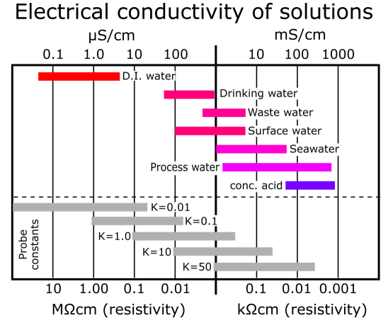

The size of the current depends on:
Nature of the ions: charge, size and mobility
Nature of the solvent: dielectric constant and viscosity
Concentration of ions: the more ions the greater the conductivity and so conductivity can be used as a measure of concentration.
Temperature

To measure conductivity, we use a machine called a conductivity meter.
How Using conductivity meter?
- Place your electrode in your sample and start reading. Once your electrode has been placed in your sample, press the measurement button and leave the electrode in your sample for about 1-2 minutes.
- Clean your electrode after use.
- Rinse your electrode with distilled water and pat dry.

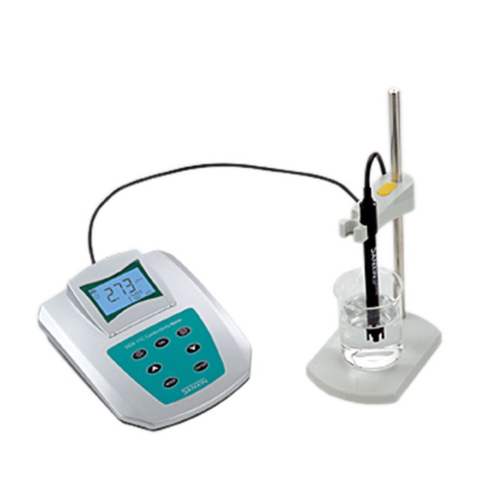 | 