CALIBRATION OF PH
What is pH?
pH is the measurement of hydrogen ion concentration ([H⁺]) of a solution. The pH is measured pH meter. Every solution can be measured to determine its pH value. This value ranges from 0 to 14 pH. Values below 7 pH exhibit acidic properties. Values above 7 pH exhibit basic (also known as caustic or alkaline) properties. Since 7 pH is the center of the measurement scale, it is neither acidic nor basic and is, therefore, called "neutral."
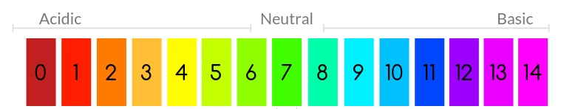
The pH is equal to minus the log of the H+ concentration. The equation that defines pH is given as follows:
pH = -log[H⁺] concentration
For example: Is the H⁺ concentration is very low, lets say about 0.0000001M, then the pH is;
pH= -log[0.0000001] or pH= -log[1 x10⁻⁷]
pH=7
How to Calibrate and Use a pH meter
Calibration
- Turn on your pH meter.

- Clean your electrode.
Take the electrode out of its storage solution and rinse it with distilled water under an empty waste beaker.
- Be sure to rinse your electrode in a waste beaker that is different from the beaker you will be calibrating in.
- Avoid rubbing the electrode as it has a sensitive membrane around it.
- If you find the electrode to be particularly dirty consult your operating manual for recommended cleaning solutions.

- Prepare your buffers.
Pour your buffers into individual beakers for calibration. Discard the buffer when you are finished. Do not return it to its original container.

- Place your electrode in the buffer and begin reading.
Press the “measure” or calibrate button to begin reading the pH once your electrode is placed in the buffer. Allow the pH reading to stabilize before letting it sit for approximately 1-2 minutes. Do the same for all other buffer solution.

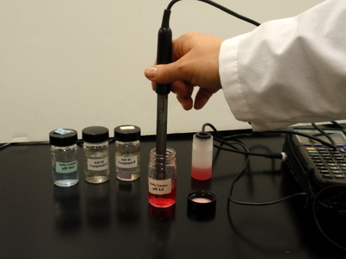

- Clean the electrode after calibration is complete. Rinse your electrode with distilled water and pat dry.

Using Your pH Meter

- Place your electrode in your sample and start reading. Once your electrode has been placed in your sample, press the measurement button and leave the electrode in your sample for about 1-2 minutes.

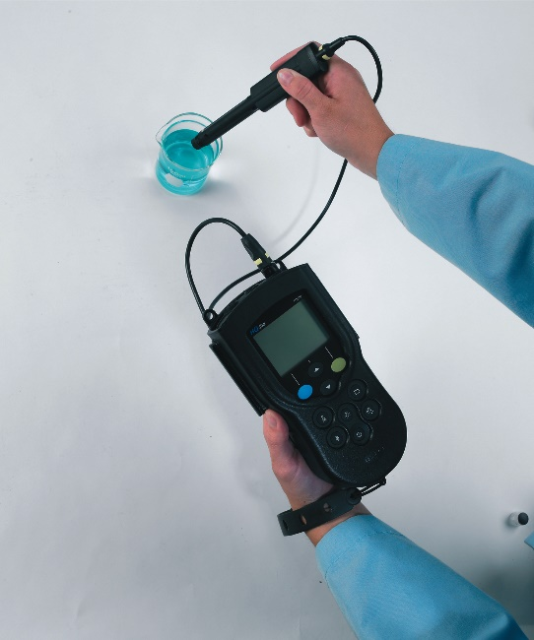

- Clean your electrode after use. Rinse your electrode with distilled water and pat dry.

